Restoration Channel Islands Debate
Criteria for Debatable Questions

You will now watch the “Restoration” movie segment about the Channel Islands ecosystem. As you watch the movie, write down some ideas for debatable topics that are brought up in the section below.
Ideas for Debatable Topics

Step 1: As a group, decide on a debatable question from the list on the board, and then write your
question on the lines below.
___________________________________________________________________________________________________________________________________________________?
Step 2: Within your group, form teams (supporting team and opposing team).
I will represent the (check one): Support Opposition
Step 3: In your team, come up with a claim/thesis statement for the side of the argument you are
Your Claim/Thesis statement:
____________________________________________________________________________________________________________________________________________________

representing.
As a class, we will watch the “Restoration” video clip again and in your teams, you will be given a set of articles. From these sources, you will need to collect 3 things:
- Three reasons that support your claim to the argument and two pieces of evidence to back up each reason.
- At least two reasons that would support your opponents’ claim and at least one piece of evidence to back up each reason.
- A counterclaim to your opponents’ reasons.
Use the space below to take notes on the video and the articles.
Your evidence:

Your opponents’ evidence:

Step 4: Caucus as a team to decide on your three strongest reasons that support your claim and the corresponding evidence for each reason. Write them on the lines below.
- I take the position that (your claim/thesis statement) ___________________________
_______________________________________________________________________
- My first reason for this is because (Reason 1) __________________________________
_______________________________________________________________________
  - My evidence is that (Evidence A): ______________________________________
_________________________________________________________________
  - Also, (Evidence B): __________________________________________________
_________________________________________________________________
- My second reason for this is because (Reason 2) ________________________________
_______________________________________________________________________
  - My evidence is that (Evidence A): ______________________________________
_________________________________________________________________
  - Also, (Evidence B): __________________________________________________
_________________________________________________________________
- My third reason for this is because (Reason 3) _________________________________
_______________________________________________________________________
  - My evidence is that (Evidence A): ______________________________________
_________________________________________________________________
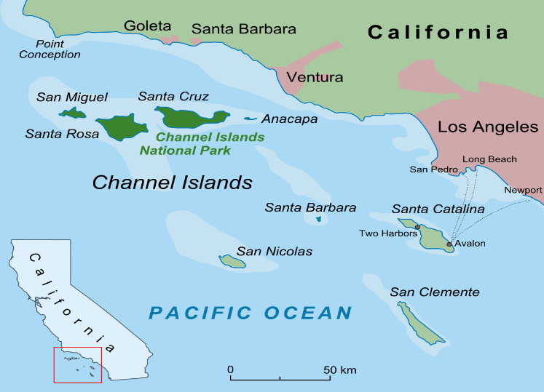
  - Also, (Evidence B): __________________________________________________
_________________________________________________________________

Step 5: Without consulting your opponents, write down what you think your opponents’ claim will be for their side of the argument.
Opponents’ Claim/Thesis Statement:
__________________________________________________________________________________________________________________________________________________

Step 6: As a team, come up with at least two reasons that you predict your opponents will use in their argument to support their claim, as well as at least one piece of corresponding evidence for each reason. Then fill in your counterargument. The bullet points in boxes are the items that MUST be completed.

- Possible Opponents’ Claim/Thesis statement __________________________________
_______________________________________________________________________
- … because (Possible reason 1) ______________________________________________
_______________________________________________________________________
  - Supporting Evidence A: ______________________________________________
_________________________________________________________________
My counterclaim: __________________________________________________
_________________________________________________________________
  - Supporting Evidence B: ______________________________________________
_________________________________________________________________My counterclaim: __________________________________________________
_________________________________________________________________
- … because (Possible reason 2) _____________________________________________
_______________________________________________________________________
  - Supporting Evidence A: ______________________________________________
_________________________________________________________________
My counterclaim: __________________________________________________
_________________________________________________________________

  - Supporting Evidence B: ______________________________________________
_________________________________________________________________My counterclaim: __________________________________________________
_________________________________________________________________
- … because (Possible reason 3) _____________________________________________
_______________________________________________________________________
- Supporting Evidence A: ______________________________________________
_________________________________________________________________My counterclaim: __________________________________________________
_________________________________________________________________
- Supporting Evidence B: ______________________________________________
_________________________________________________________________
My counterclaim: __________________________________________________
_________________________________________________________________
Let’s Have a Scientific Debate!
You will be paired with another debate group to watch and listen as they debate their question.
Observing Team Rules:
Debating Team Rules:
- Each side gets one minute to present (page 3).
- Same-team partner may whisper in or write notes to each other (on post-its).
- Opposite side takes notes (page 6).
- Caucus! This time compare notes and decide which of your opponents’ points were strongest- how could you respond to them (page 7)?
- Each team will have an additional minute to respond with their counterargument (page 7).
- Shake hands and congratulate each other on a successful debate.

- Watch each team present for one minute.
- You should not talk at this time.
- Take notes on each team’s argument (page 8).
- Discuss the strongest points that each side of the argument presented and write them in your notebooks (page 8). Discuss and write down what each team has done well and things they could improve on (page 8).
- Listen to the group present their counterargument.
- Applaud and congratulate each team on a successful debate.

NOTE: If your group is debating second, go to Step 10.
Step 7: Debate your side of the argument by reading out your reasons and evidence in
Step 4 (page 3).
When it is your opponent’s turn to debate, take notes on their argument using the space below.
- (Opponents’ Claim/Thesis statement) ________________________________________ _______________________________________________________________________
- … because (Reason 1) _____________________________________________________
_______________________________________________________________________
  - Evidence A: _______________________________________________________
_________________________________________________________________
  - Evidence B: _______________________________________________________
_________________________________________________________________
- … because (Reason 2) _____________________________________________________
_______________________________________________________________________
  - Evidence A: _______________________________________________________
_________________________________________________________________
  - Evidence B: _______________________________________________________
_________________________________________________________________
- … because (Reason 3) _____________________________________________________
_______________________________________________________________________
  - Evidence A: _______________________________________________________
_________________________________________________________________
  - Evidence B: _______________________________________________________
_________________________________________________________________

Step 8: Caucus! Use the space below to determine evidence for your counterclaim
defense.
- I respectfully disagree with (Opponents’ Claim/Thesis Statement) __________________
______________________________________________________________________________________________________________________________________________
- I respectfully disagree with your first reason because (Counterclaim 1) ______________
______________________________________________________________________________________________________________________________________________
  - My evidence for that is (Evidence A): ___________________________________
_________________________________________________________________
  - Also, (Evidence B): __________________________________________________
_________________________________________________________________
- I respectfully disagree with your second reason because (Counterclaim 2) ___________
______________________________________________________________________________________________________________________________________________
  - My evidence for that is (Evidence A): ___________________________________
_________________________________________________________________
  - Also, (Evidence B): __________________________________________________
_________________________________________________________________
- I respectfully disagree with your third reason because (Counterclaim 3) _____________
______________________________________________________________________________________________________________________________________________
  - My evidence for that is (Evidence A): ___________________________________
_________________________________________________________________
  - Also, (Evidence B): __________________________________________________
_________________________________________________________________
Step 9: Give your counterclaim defense by reading the statements in Step 8.

Shake hands with your opponent and congratulate them on a successful debate.

Step 10: Take notes on your partner group’s debate in the box below.
Notes on Opposition arguments:

Notes on Support arguments:

Debrief
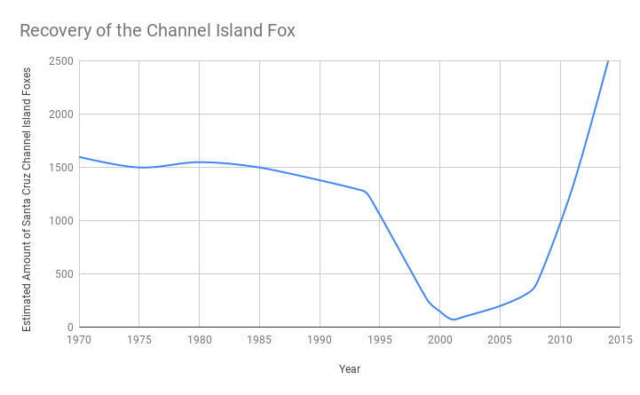
Use the graph below to answer the following questions.
- In one sentence, describe what data this graph contains.
____________________________________________________________________________
____________________________________________________________________________
- What is the time frame for this graph? ______________________________________________
- Why do you think the graph begins in 1970?
____________________________________________________________________________
____________________________________________________________________________
- What does it mean for a population to be stable?
____________________________________________________________________________
- Put a box around where the population of foxes was relatively stable on the graph.
  - In what years was the population stable? _______________________________________
- Name 2-3 factors that the foxes must have had on Santa Cruz Island for the for population of foxes to remain stable during this time period.
________________________________________________________________________________________________________________________________________________________
- What does it mean for a population to be changing?
____________________________________________________________________________
- Put a circle around where the population of foxes was dramatically changing on the graph.
  - Did the number of foxes show a dramatic decrease in population on the graph?
Yes No
  - If yes:
    - In what years was the population dramatically decreasing? __________________
    - On your graph, label this circle with a “D”.
  - Did the number of foxes show a dramatic increase in population on the graph?
Yes No
  - If yes:
    - In what years was the population dramatically increasing? ___________________
    - On your graph, label this circle with an “I”.
- Think back to the video and articles. Name 2-3 factors that could have caused the foxes to decrease in number.
____________________________________________________________________________________________________________________________________________________________________________________________________________________________________
- Think back to the video and articles. Name 2-3 factors that could have caused the foxes to increase in number.
____________________________________________________________________________________________________________________________________________________________________________________________________________________________________
- From questions 9 and 10, we know that there were many factors influencing the fox population. On the graph, put a star when you think these factors began to have a significant negative effect on the fox population.
- Scientists decided to remove the pigs from the island once they realized the negative impacts they had on the fox population. Put an X on the graph where you think scientists began to remove the pigs.

- What do you think would happen to the foxes if the feral pigs were still alive on the island?
If the feral pigs were still alive, then _____________________________________________
______________________________________________________________________________________________________________________________________________________
- Do you think this issue is complex and leads to more argumentation? Why?
______________________________________________________________________________________________________________________________________________________

