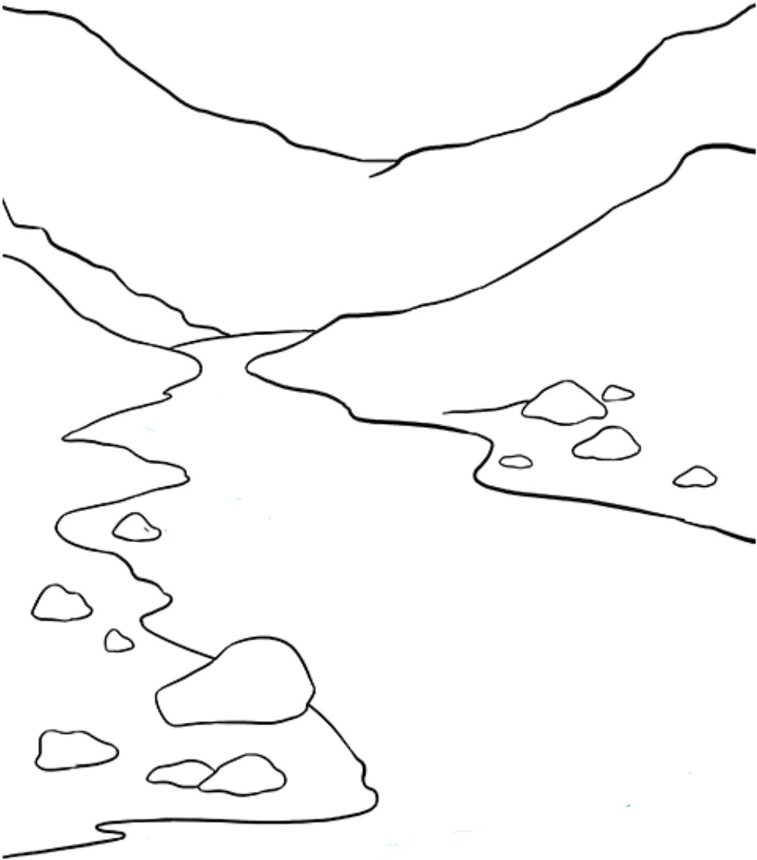
If I was at the __________, I could find _____________________________
Name What I Learned About Rivers

