Follow Your Nose

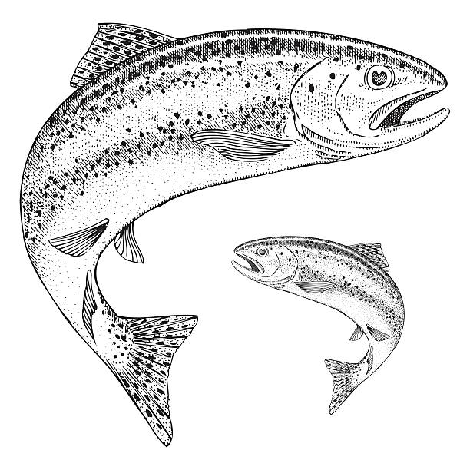
Part I: Hooks and Ladders

- Thinking back to the Hooks and Ladders activity, what were some of the dangers that threaten a salmonid’s survival? List them below:

___________________________________________________________________________________________________________________________________________________________________________________________________________________________
Part 2: The Salmonid Life Cycle
Part 2A - Jigsaw: What Salmonids Need to Survive

- With your group, read your Survival Needs card. What does a salmonid need in order to survive at the life cycle stage assigned on your card?
A salmonid at the _____________________ stage needs:

___________________________________________________________________________________________________________________________________________________________________________________________________________________________
- In your mixed group, order the cards with the life cycle stages from first to last. Then check with your teacher to see if you are correct. Once your teacher confirms your answer, use your cards to fill in the blanks below in the correct order.

A salmonid begins its life as an _____________________ . Once it hatches, it is called an ____________________ . It absorbs its yolk sac and becomes a ___________ . Then, it swims downstream as a _________________ . Once it’s ready to live in saltwater, it swims into the ocean as an______ _______________ . When it is ready to spawn, the salmonid is called a ________________________ . It returns to its home stream to lay or fertilize eggs.

Part 2B - Diagram: Life Cycle of the Steelhead Trout

- Steelhead trout are a species of salmonid that live in Arroyo Burro Creek. With your mixed group, you are going to create a diagram of the steelhead’s life cycle.
Before you begin:
-- Talk together and agree on some things to include before anyone starts drawing.
-- Your diagram should include the following:
⬚ A color-coded key with a different colored dot to represent the steelhead at
each stage of its life cycle. We will fill in the colors of the key together.
⬚ Dots showing where the steelhead live at each stage of their life cycle.
⬚ Arrows to show the movement of the steelhead throughout its life cycle.
⬚ A title that says what the diagram shows.
⬚ In the Puzzle Box, write something that still puzzles you.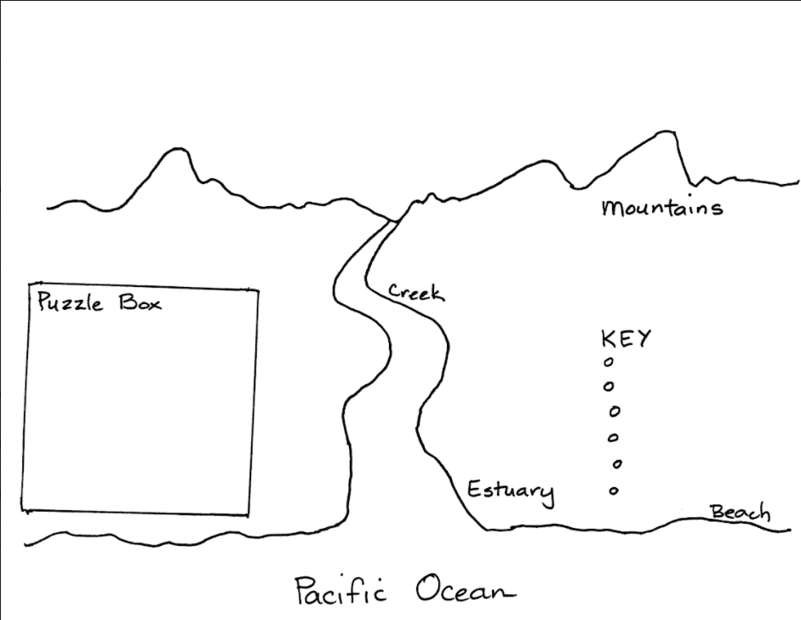
- Take turns with your group sharing the survival needs of a salmonid at each stage of its life cycle. As you share, add text boxes to your diagram to explain how the ecosystem meets the steelhead’s needs at each stage of its life cycle.

Part 3: Follow Your Nose Home
Part 3A. Finding Your Way

- How do people find their way from one place to another?
__________________________________________________________________________________________________________________________________________________

- Describe your route from school to home. What landmarks would you use to tell a friend how to get there?
___________________________________________________________________________________________________________________________________________________________________________________________________________________________

- Luis walks home from school everyday by following the route below. If Luis were to be blindfolded, could they still find their way home? What would help Luis know they are heading in the right direction?
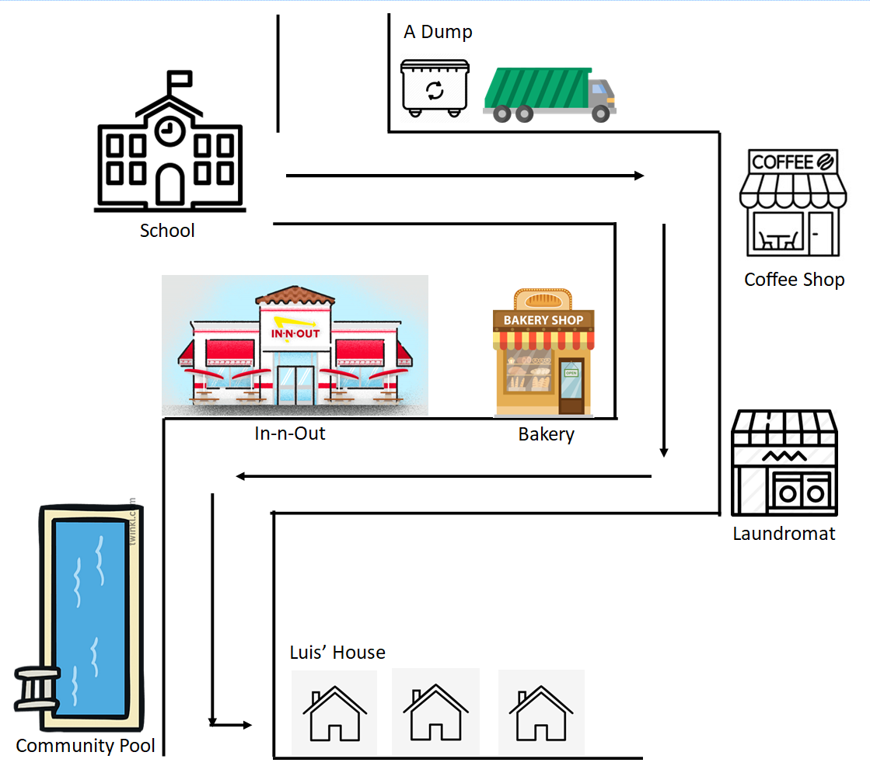 | ________________________________________________________________________________________________________________________________________________________________________________________________________________________________

Part 3B. How Salmon Scent Their Way Home Again
- After spending two to ______________ years in the ocean, depending on the species, adult salmonids leave the ocean and return to their _____________________________ to ________________________.
- How do adult salmonids find their way to the mouth of their home stream where they hatched? Scientists think salmonids use ocean ______________________ and water __________________________ to find their way back to the mouth of their home stream. Then, they use odors in the water to find the exact part of the stream where they were born.

Part 3C. Structure and Function of Salmonids
With your small group, use the Internal and External Structures of the Salmonid Diagram on your table to identify the external and internal structures of the trout and their functions.
External Structures
Structure | Function
1. | fin at the tail end of the trout that moves the salmonid forward
2. | fin on the dorsal side (top) of the salmonid that helps the fish turn and balance
3. | structure along the side of the salmonid that allows the fish to detect movement, vibration, and pressure changes in the water and helps the fish navigate
4. | salmonid uses these to see
5. | salmonid uses this to eat and breathe (fish opens and closes this to move water over the gills)
6. | bony flap that covers and protects the gills
7. | pair of fins on each side of the fish just behind the gills, used for balancing and braking
8. | located on the belly of fish and help with steering and balance
9. | located on the ventral side (underside) of the salmonid, just before the caudal fin; helps the fish remain stable in the water
10. | protect salmonid’s skin from predators, parasites, and injuries
11. | salmonid uses to detect odors in the water
12. | opening that releases waste (poop)
Internal Structures
Structure | Function
13. | identifies and remembers odors
14. | nerve processing center
15. | digests food
16. | absorbs oxygen from the water

- The external structure of its body that a salmonid uses to sense odors in its environment are called its ___________________ or _____________ . The internal structure that a salmonid uses to detect scent is called its _____________________________ . How do these structures function to help salmon and trout survive to reproduce?

__________________________________________________________________________________________________________________________________________________
Part 4: Smell Like a Salmonid
- What do you think makes a stream smell a particular way to a salmonid?
__________________________________________________________________________________________________________________________________________________

- We are going to do an activity to test whether we can find our way “home” using our sense of smell.
Put a check next to your salmonid type:
▢ Chinook  ▢ Coho Salmon  ▢ Steelhead Trout | ▢ Sockeye Salmon  ▢ Golden Trout  ▢ Chum Salmon
- Make a prediction: (circle one) It will be easy / difficult to find my “home” using my sense of smell.
- Wait for directions from your teacher!
- Was your prediction correct? Were you able to find your “home” using your sense of smell?
Yes / No It was easy / difficult .

- After the second trial, were you able to find your “home” using your sense of smell?
Yes / No It was easy / difficult .
- Was there anything that differed between trial 1 and trial 2?

__________________________________________________________________________________________________________________________________________________
- What do you think could have caused this?
__________________________________________________________________________________________________________________________________________________

- Look back at your diagram on page 3. After learning about the structure and function of salmonids and after reading the text, what can you add to your diagram? Add to it now.

- Now write an explanation that answers the question “How do salmonids find their way back to their home stream?”
Claim:
__________________________________________________________________________________________________________________________________________________

Evidence #1:
___________________________________________________________________________________________________________________________________________________________________________________________________________________________

Reasoning:
___________________________________________________________________________________________________________________________________________________________________________________________________________________________
Evidence #2:
___________________________________________________________________________________________________________________________________________________________________________________________________________________________

Reasoning:
___________________________________________________________________________________________________________________________________________________________________________________________________________________________

Part 5: Effects of Wildfire on Salmonids
Together, we are going to read an informational text called Fish and Fire: How Wildfires Affect Salmon and Trout.
Wildfire is harmful Wildfire is helpful
- What are some of the ways wildfire can harm salmonids?
___________________________________________________________________________________________________________________________________________________________________________________________________________________________

- Give some examples of ways that wildfire might be helpful to organisms in a riparian habitat.
___________________________________________________________________________________________________________________________________________________________________________________________________________________________

Part 6: Constructing an Explanation:

- Fish biologists counted steelhead fry in Arroyo Burro Creek each April over a ten-year period. Here is a table showing the data they collected:
Year | # of fry counted
2008 | 13
2009 | 17
2010 | 0
2011 | 0
2012 | 0
2013 | 1
2014 | 1
2015 | 3
2016 | 2
2017 | 6
2018 | 9

- What do you notice about this data? ____________________________________________
_________________________________________________________________________
- What could have caused the change in fish population?
__________________________________________________________________________________________________________________________________________________
- In May 2009, the Jesusita Fire burned 35 square kilometers in Santa Barbara, including areas along Arroyo Burro Creek. What changes do you think the fire made to the steelhead’s habitat? ________________________________________________________

_________________________________________________________________________
_________________________________________________________________________

- How might these changes have caused steelhead fry to disappear from the stream in 2010?

_________________________________________________________________________________________________________________________________________________
- Construct an explanation for how the steelhead population increased from 0 fry after the Jesusita Fire in 2010 to 50 fry in 2018. Remember to include a claim, at least 1 piece of evidence, and reasoning in your explanation.
____________________________________________________________________________________________________________________________________________________________________________________________________________________________________________________________________________________________________
- What do you wonder now?
___________________________________________________________________________________________________________________________________________________________________________________________________________________________

