Human Impact

How has human activity affected different ecosystems?

Vocabulary:
System: A set of things working together in an interconnecting network.
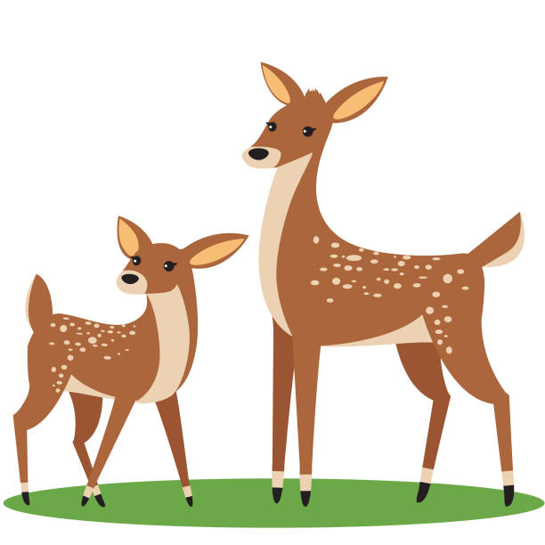
Ecosystem: A community of organisms interacting with each other and with the nonliving environment.

Part 1. Forest Ecosystem Model

Ecosystem Model Terms:
Home Range: Coned off section of the playground
Deer Population: Amount of Ziploc bags held by students
Deer Casualties: Amount of Ziploc bags on the ground

Ecosystem Model Rules:
- One year equals one minute.
- Deer food is represented by pasta.
- Deer that eat 5-10 pieces of pasta, in one year, live and have one offspring.
- Deer that do not eat 5-10 pieces of pasta, in one year, either overeat or starve and therefore, die and must drop their Ziploc bag on the ground.

Year | Number of Deer  at Start of Year | Number of Deer  that Survived | Explanation
1
2
3
4

- Year 2, started with _____________ deer and _____________ survived. The number of deer in that year increased stayed the same decreased because__________________________
Circle One
_______________________________________________________________________________
- Year 4, started with _____________deer and _____________ survived. The number of deer in that year increased stayed the same decreased because__________________________
Circle One
_______________________________________________________________________________
- What were the parts of this ecosystem? ______________________________________________
_______________________________________________________________________________
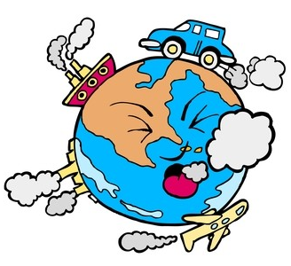
- Do the parts of the ecosystem affect each other? (Circle One) Yes No
Part 2: Observing Human Impact

Directions: Your group will be assigned an ecosystem to investigate. You will get two maps of the same location each showing a different time period.

- What ecosystem was your group assigned? ____________________________________________
- Look at the oldest map of your ecosystem and describe the different land, water, and plant features in the area.______________________________________________________________
______________________________________________________________________________________________________________________________________________________________
- What parts of your ecosystem changed (living and nonliving)? ____________________________
_______________________________________________________________________________
- The changes to the ecosystem during the given time period were: Positive Negative
Circle One
- What human activity or activities caused these changes? ________________________________
_______________________________________________________________________________
**As a class review human impact vocabulary.**
- Get post-it it note from your teacher. Write the following on your post-note:
  - Name of your ecosystem
  - Human activity(ies) that impacted the ecosystem
  - Indicate with a + or – if it was a positive or negative change
Be prepared to share this information with the class and place the post-it note on the correct location on the world map.

- For each location decide which of the following categories influenced the observable changes and/or the environment. Mark each box with a (+) for a positive change and a (–) for a negative change. Then put the letter next to the location name on the world map below.

Location | Deforestation | Pollution | Resource  Extraction  (e.g.: mining) | Land Development | Climate  Change | Increasing Human Population
A. US: New Mexico
B. Japan
C. US: Alaska
D. Kenya
E. Brazil
F. US: California
G. US: Virginia
H. Australia
I. Romania
J. US: New York
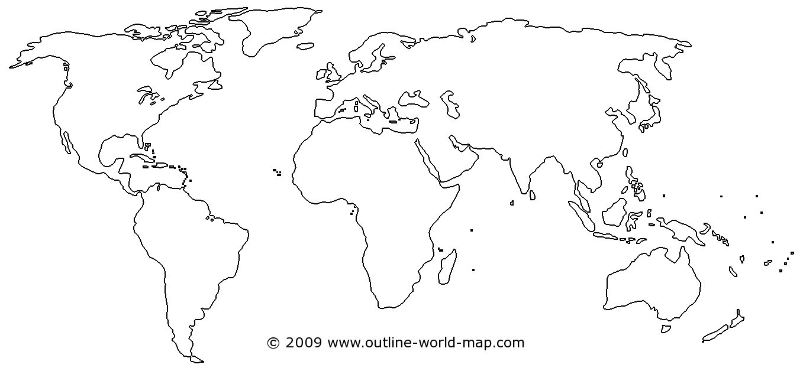

Part 3: Predicating Human Impact:

- Look at the map of Maui. The white areas represent cities known as urban areas. Make a claim about how people have influenced the natural system in Maui.
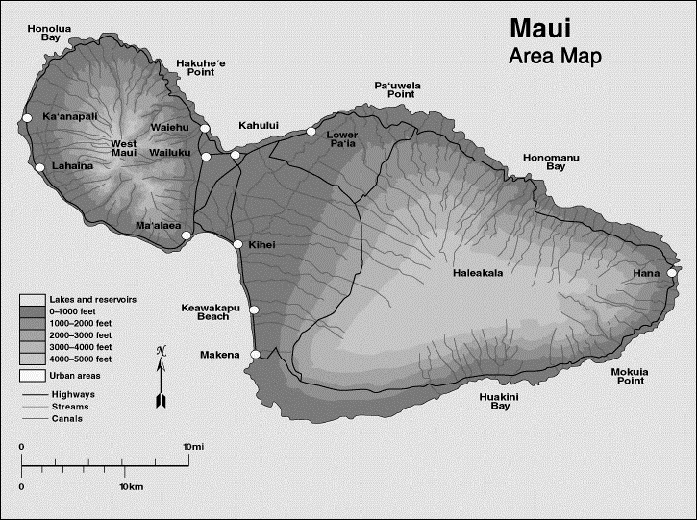

(Claim) We think people have ______________________________________________________
_______________________________________________________________________________
(Evidence) We reached this conclusion because in ______________________________________
Location
between ___________________ and ___________________ we saw_______________________ _______________________________________________________________________________
Date Date
(Reasoning) This shows____________________________________________________________
_______________________________________________________________________________

- Draw a model of Maui Island with the changes you predict will happen to the island’s ecosystem if the population doubles. Shade the populated areas with pencil and color in the forested areas green.

- Explain your drawing:_____________________________________________________________
___________________________________________________________________________________________________________________________________________________________________________________________________________________________________________________________________________________________________________________________________________________________________________________________________________

