Walking in a Water ☔ Wonderland
Graph 1: Household Water Use
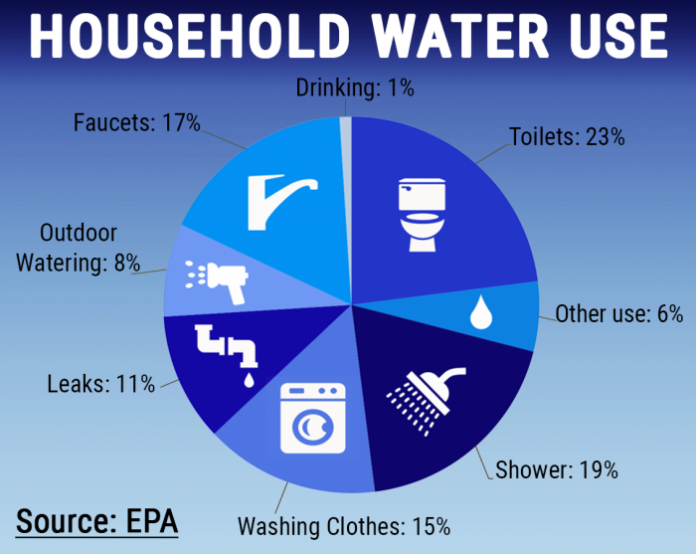
Is water really that important? To answer this question let’s look at the life of a typical 6th grader. They get up in the morning and the first thing they do is go to the bathroom, flush the toilet (1.6 gallons [gal]), and wash their hands (1 gal). They then sit down to a breakfast of eggs (53 gal) and toast (24 gal). It is now time to get dressed, so they go to the dryer and pick out clean clothes for the day (20 gal per load). They slip on their t-shirt (766 gal) and jeans
(20,000 gal) and are ready to be driven to school (13 gal of water per gal of gas). In the morning they use 5 sheets of paper for their classwork (10 gal). Then it’s time for lunch. They eat an apple (18 gal), a turkey sandwich (162 gal), and a bag of chips (49 gal). After lunch, the class goes out to play soccer (1000 gal per day to water the field) for PE. When the school bell rings, they go home and help make burgers (699 gal) for dinner. After dinner it is their night to wash the dishes (17 gal). With the dishes done, there is time to relax and watch TV for a couple of hours (5 gal in electricity use) before they take their shower (17 gal), brush their teeth (1 gal), and go to bed. By the time the day is over, most people do not realize that they have used more than 100 gallons of water directly as well as countless gallons indirectly (Graph 1, Figure 1). We rarely stop to think about the important role water plays in our lives. In fact, water is so important that if there were no water on Earth there would be no living things on the planet.
Figure 1: Where our Water is Used Over 24 Hours
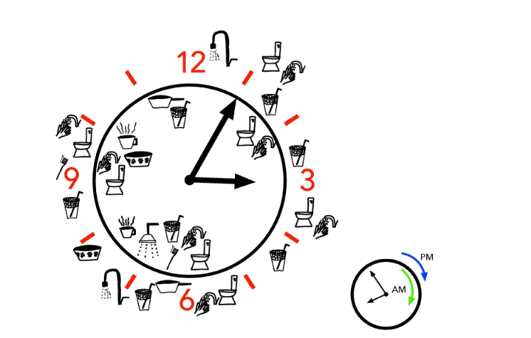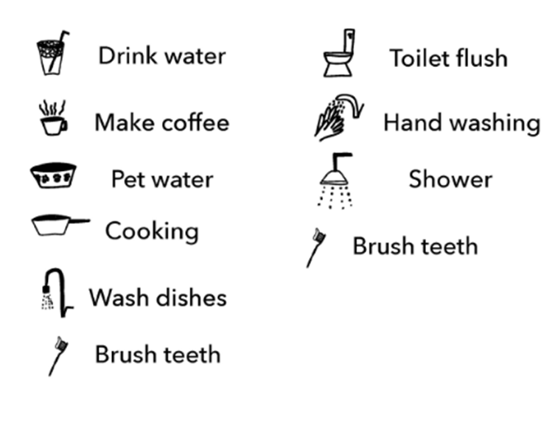

Graph 2: Water Sources County
of Santa Barbara
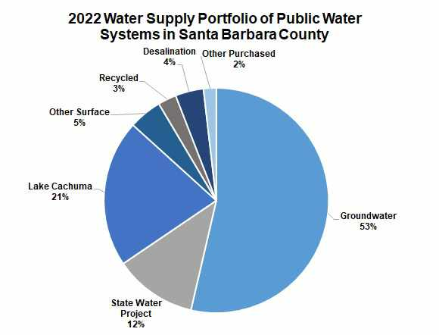

If we use so much water, where does it come from? In Santa Barbara County, the water that comes out of our faucets comes from four main sources: groundwater, reservoirs, desalination, and water provided by the State of California commonly called State water. The pie charts show the percentages of water that come from these sources for the County (Graph 2), as well as for Santa Barbara (Graph 3) and Goleta (Graph 4).

Graph 4: Water Sources Goleta
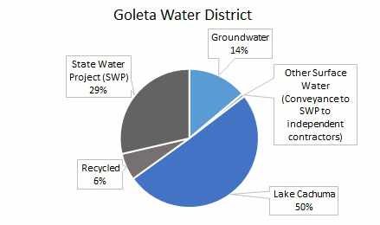
Graph 3: Water Sources Santa Barbara
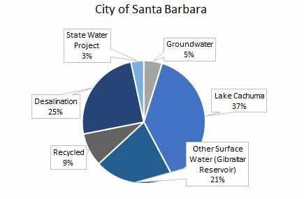

Map 1: Groundwater Locations
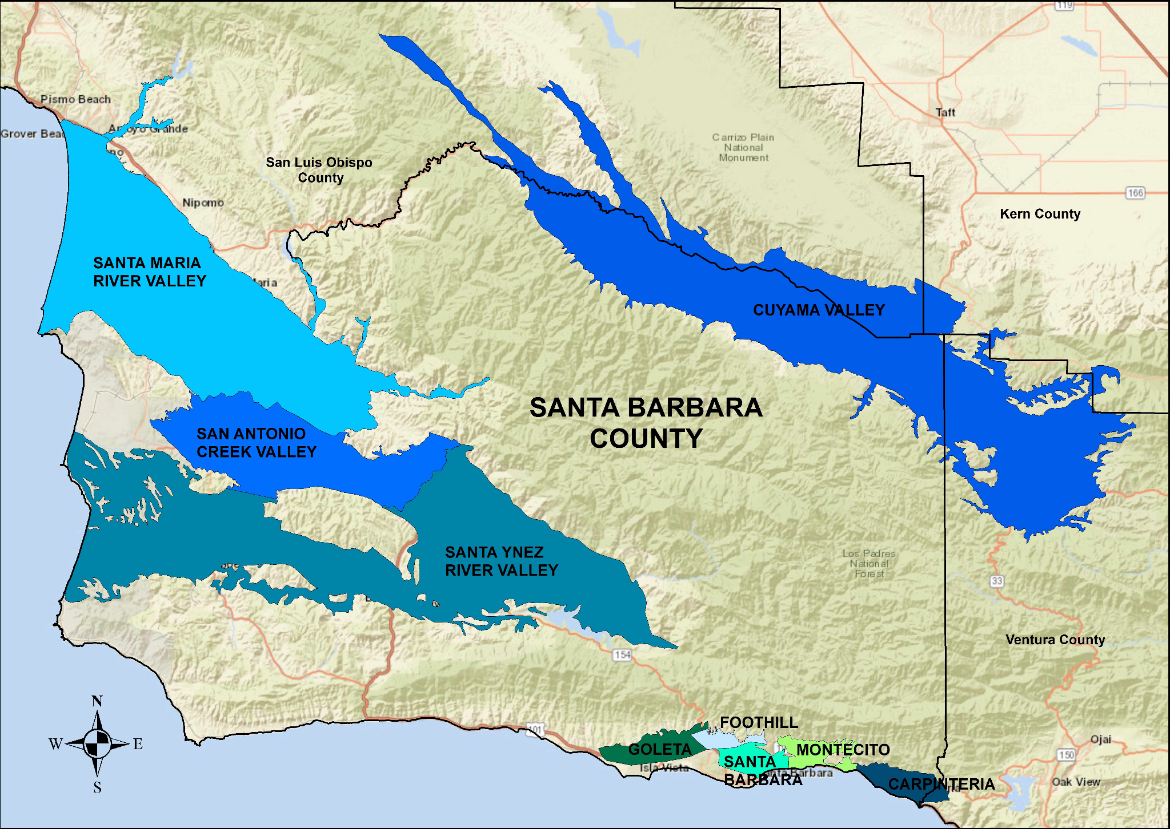

Let’s take a closer look at each of these sources of water. The first is groundwater. As the name suggests, this is water located underground that can be accessed through deep holes drilled into the ground, commonly known as wells. Map 1 shows the location of groundwater in Santa Barbara County.

The second source of water is reservoirs. The two largest reservoirs in Santa Barbara County are Twichell Reservoir, which holds 243,928,000 cubic meters (m³) and Lake Cachuma which holds 238,437,000 m³. These reservoirs are located in the hills above Nipomo and Santa Barbara respectively, shown on Map 2. Each of these reservoirs holds about enough water to supply all of the people in the County with water for 1.5 years if they are not refilled.
Map 2: Santa Barbara Reservoirs and their . Watershed
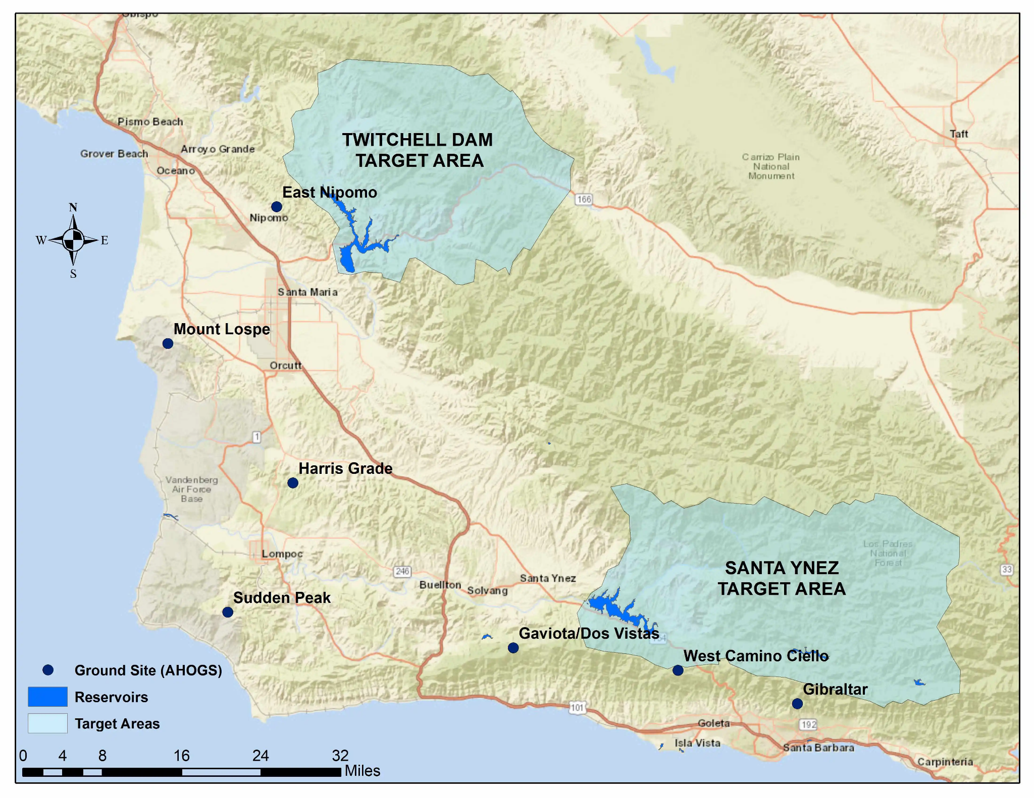

The third source of water is desalination, a process by which saltwater is turned into potable (drinkable) water. This is possible since Santa Barbara is located next to the ocean. Making freshwater from saltwater is a very energy intensive process that produces water that is 75% more expensive than water that comes from groundwater or reservoirs.
Map 3: State Water Canals and Pipelines
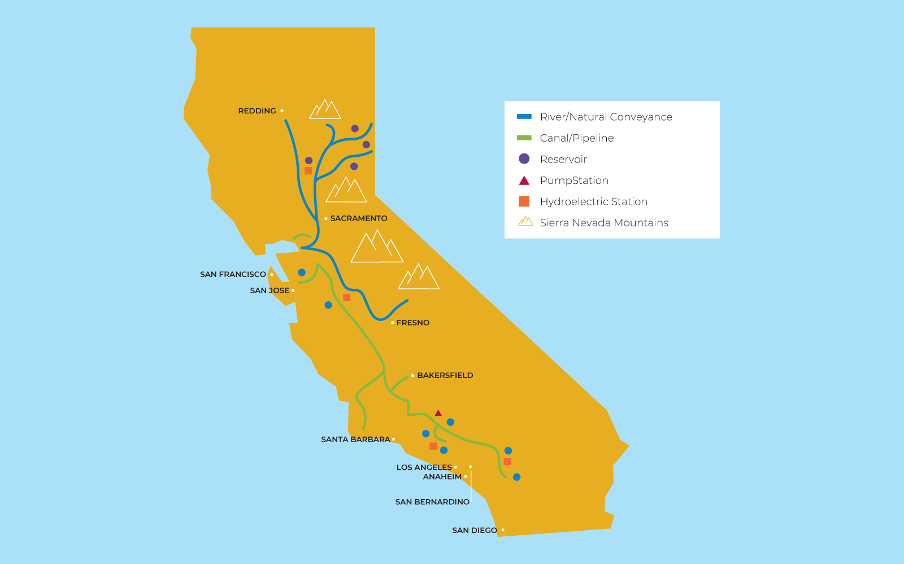

The final major source of water is State water. In order to have water during drought conditions, a common occurrence in Santa Barbara, we need to transport water in from other parts of the state. Southern California accounts for approximately 80% of the water needs in California, however approximately 45% of California’s water comes from the San Joaquin River Delta in Northern California. The state has canals and pipelines that bring this water to Southern California, including Santa Barbara County (Map 3).

On Earth there are two types of water: salt water and fresh water. Salt water makes up 97% of the water on Earth. If you look closely in your community, you will find a lot of different water sources such as: creeks, streams, rivers, lakes, ponds, reservoirs, and the ocean. Some of these water sources contain water year-round and others contain water only during certain seasons. But how does water get into these sources? One way that water enters these sources is through precipitation. Precipitation is when water is released from clouds in the form of rain, sleet, snow, or hail. The type of precipitation that falls is dependent on the temperature. If the temperature is below 0°C (32°F) the liquid water loses energy and turns into solid water (snow or hail). This process is known as freezing and the reaction for it is: H₂O(l) H₂O(s) + heat. If the temperature is above 0°C, the precipitation is in the form of liquid water (rain). If the temperature is at approximately 0°C then you can get sleet which is a mixture of ice, rain, and snow. Since 71% of the Earth’s surface is covered in water, most of the precipitation falls directly into these water sources.

Many water sources such as creeks and rivers start in the mountains, at high elevation. As the precipitation fills them, gravity start to pull the water downhill. Gravity is the force of attraction between anything that has mass (i.e: an object) and the Earth, which pulls the object towards the center of the Earth. You can see gravity in action when you drop a pen and it is pulled to the ground. As water is pulled downhill, several smaller sources of water can combine to form a larger water source such as a river. Several rivers can flow into a lake or reservoir. The area in which all of the streams and rainfall flow into a common outlet is known as a watershed. Coastal watersheds often flow into the ocean since they are at the lowest elevation, which is referred to as sea level.

Even though most of the Earth’s surface is water, not all precipitation falls directly into a water source. Some of the water falls onto land. When this happens, the water can be absorbed into the soil, Figure 2. If the soil is already waterlogged, however, it can be pulled by gravity into another water source at a lower elevation which is referred to as runoff. Even the process of absorbing water into the Earth is driven by gravity. Percolation is the movement of water down through the soil itself. The rate at which water passes through the soil is dependent on the type of soil. Groundwater is stored in cracks and spaces in soil, sand, and rock and is known as an aquifer. Groundwater makes up 29% of the freshwater on Earth. To access this water, people have to dig wells. Wells are deep holes in the ground that allow water to seep into them. Once the water is in the hole, the water can be pumped to the surface for use. These wells have to be drilled deep enough to reach the water table, or the level at which the ground is saturated with water. The groundwater also flows laterally in a process called infiltration. This connects the groundwater to other water sources such as lakes and the ocean. In coastal areas it is important that scientists monitor the groundwater levels to make sure that people are not removing too much water from the water table. If people remove too much groundwater, it will cause the water table to be below sea level. If this happens, it causes salt water to seep into groundwater sources making them unusable.
Figure 2: Groundwater
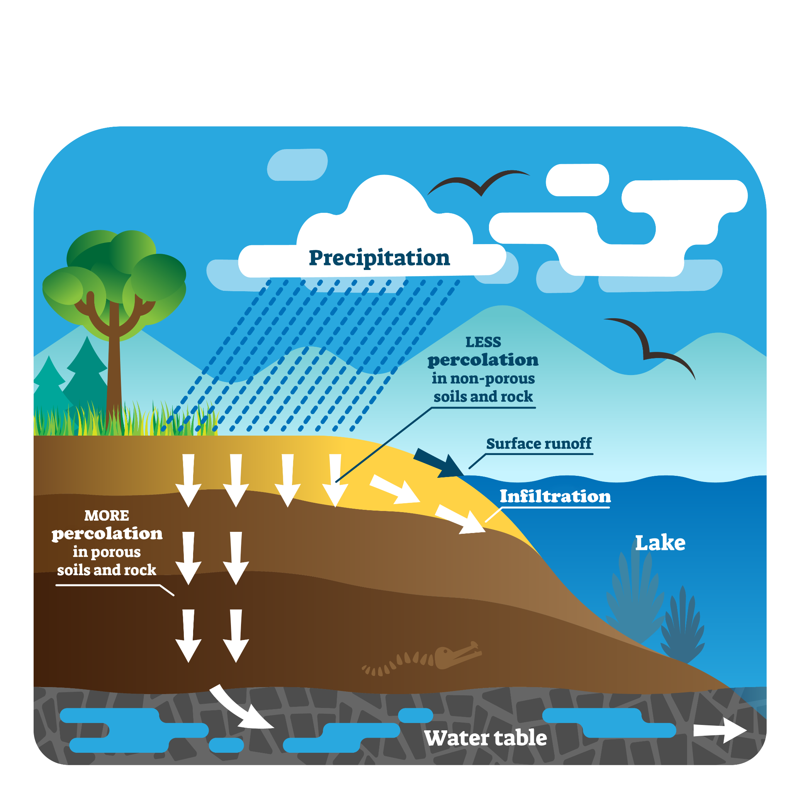

It makes sense that when it is raining, creeks and rivers flow. But why do they keep flowing even after the rain has stopped? The two main sources that keep rivers and creeks flowing are snowpack and springs. First, let’s explore snowpack. When the snow falls on the ground it stays frozen as snow (solid water). For solid water to become liquid water, known as melting, energy in the form of heat is needed. The reaction that happens is H₂O(s) + heat H₂O(l). Until the temperature is above 0°C (32°F), the snow will not melt. When the temperature starts to warm in the spring, the snow starts to melt, which allows water to be absorbed into the ground or slowly run off into nearby water sources. It takes about 8 weeks (2 months) for the snowpack to melt in the Sierra Mountains, the largest snowpack in California. During this time, runoff will slowly feed nearby water sources. Approximately 30% of the water that we use in California comes from melting snowpacks.

This explains why rivers and creeks run during the rainy season as well as a few months into the dry season. But there are some rivers that run year-round. What feeds these rivers? These rivers get some of their water from springs. Springs allow groundwater to resurface (Figure 3). How does this happen? As gravity pulls the water deeper into the ground, the water has more force acting on it (is at a higher pressure). Since the land is not flat, if the elevation drops, the pressure on the groundwater can cause it to bubble up from the ground. These groundwater seepages are called springs, and they can slowly feed rivers and creeks all year round.
Figure 3: Spring
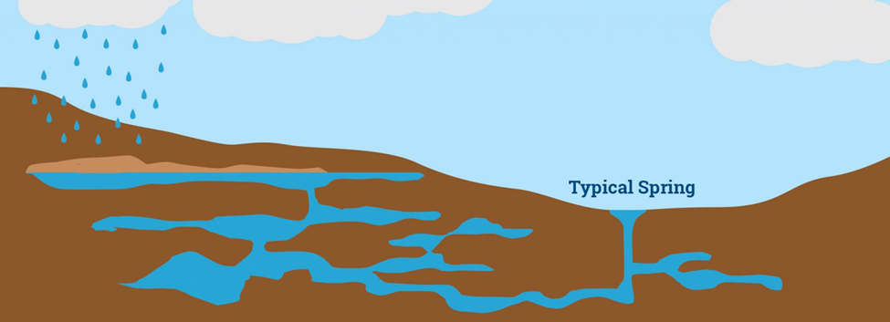

Now that we have explored how water gets into our water sources and flows on the ground, we need to explore the water in the atmosphere. Is the atmosphere able to create an unlimited amount of water? The answer is no. Water, like any other form of matter, takes up space and has mass, and therefore cannot be created or destroyed. Instead, the water has to be transferred from location to location. During these transfers it is also possible for the water to take different forms (solid, liquid, and gas). When water reaches the land as precipitation, how does water move from the land to the atmosphere? 90% of the water returns to the atmosphere through a process called evaporation.

Evaporation allows liquid water to be converted to gaseous water. For this to happen, energy must enter the water through the following reaction: H₂O(l) + heat H₂O(g). Typically, the water gets this energy from the Sun. The hotter the temperature, the greater the amount of water that will evaporate. In areas like Antarctica where there is no liquid water, is it still possible for gaseous water to enter the atmosphere? Yes, through a process called sublimation in which solid water turns into a gas. This process also requires energy to enter the solid water. The reaction for this process is H₂O(s) + heat H₂O(g). The amount of water that enters the atmosphere via sublimation is much less than 1%. You might have experienced sublimation before. Have you ever looked at an ice tray in the freezer and noticed that the ice is not full to the top, but you remembered that you filled the tray full of water? This is because just like snow and ice in the environment, ice in your freezer can sublimate, which results in the ice in the tray shrinking.

If 90% of the water in the atmosphere comes from evaporation, where does the other 10% come from? It turns out that plants play a critical role in the water cycle. Plants are able to extract water from the ground through their roots. About 2% of that water is used in photosynthesis, the process in which plants get energy from the sun and convert water and carbon dioxide into glucose and oxygen (O₂). Glucose is used by the plant as food, while O₂ is given off as a waste product. What happens to the other approximately 98% of the water? This water helps transport minerals and nutrients to the plant and is ultimately given off through the plant's leaves through a process called transpiration (Figure 4). An acre of corn gives off about 13,300 L (3,500 gal) of water each day. During transpiration the following reaction occurs (H₂O(l) H₂O(g)). Does this reaction look similar to any other reactions that we have seen? Do you think energy is involved in this process? This process is the same as evaporation, and just like evaporation, energy is needed for this process to happen. The plant itself provides this energy in the form of heat. When energy and water leave the plant, it causes the plant to cool down, this can result in the plant leaves being approximately 2°C lower than the ambient temperature.
Figure 4: Transpiration
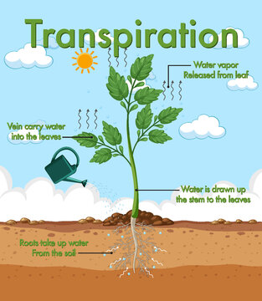

Transpiration can also help provide water for the plant. Didn’t we just say that transpiration causes water to leave the plant? Yes, that is true, but in the process, it cools the plant down to below ambient temperature. So, what does this have to do with helping the plant get water? Have you ever gone outside and noticed that the bench and other objects are wet even if it has not been raining? If so, you have experienced condensation, the process in which gaseous water turns into a liquid water by the following reaction: H₂O(g) H₂O(l) + heat. For this process to happen, energy has to leave the water. If a water particle in the air collides with an object at a lower temperature, energy can be removed from the water, allowing the gaseous water to become a liquid. This is often called dew. Dew can collect on benches, plant leaves, or other objects. If enough dew collects on the plant leaves, it can drip into the soil, watering the plant even if it is not raining. A process similar to condensation is called deposition. Deposition can happen if the temperatures are below 0°C, which causes gaseous water to be deposited on a surface as solid water. Similar to condensation, energy must leave the water
(H₂O(g) H₂O(s) + heat). Therefore, it requires gaseous water in the atmosphere to hit a surface that is a cooler temperature than the ambient air.

Not only does condensation happen on objects on the ground, but it also happens in the atmosphere. The atmosphere is made up of air masses. Air masses can be hundreds to thousands of square miles in length. Deep air masses can be up to 10 miles high, while shallow air masses are less than a mile high. Each air mass is a body of air with generally uniform temperature and humidity (the amount of water in the air). When water in a warmer air mass hits a colder air mass, it can cause the gaseous water to lose energy and turn into liquid water. This process is facilitated by dust particles in the air. Dust particles act as a starting site for the water to condense on. As more and more water particles condense, they form water droplets, which collect together and form the clouds we see (Figure 5). Clouds can contain both liquid and solid water.
Figure 5: Cloud Formation
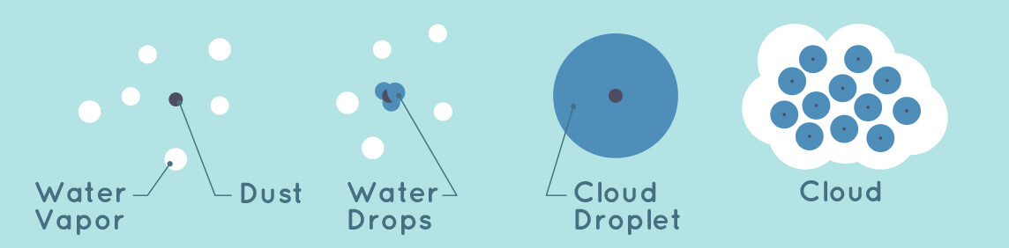
We have seen that plants play a critical role in the water cycle, but do animals play a role as well? If you breathe into a plastic bag or onto a mirror you can see tiny water droplets appear. These water particles are generated through respiration, the process by which the oxygen we take in along with glucose within our bodies is converted into energy, carbon dioxide, and water. This water is expelled into the atmosphere. While we do emit water, we also take in a lot of water through direct consumption (drinking water) and indirect consumption (eating foods that contain water). Therefore, animals do not play an appreciable role in the water cycle through respiration. However, unlike other animals, humans can influence the water cycle by extracting groundwater, seeding clouds (putting substances in the atmosphere to make it rain), as well as changing where water is located.
Figure 6: Water Movement in Water Cycle
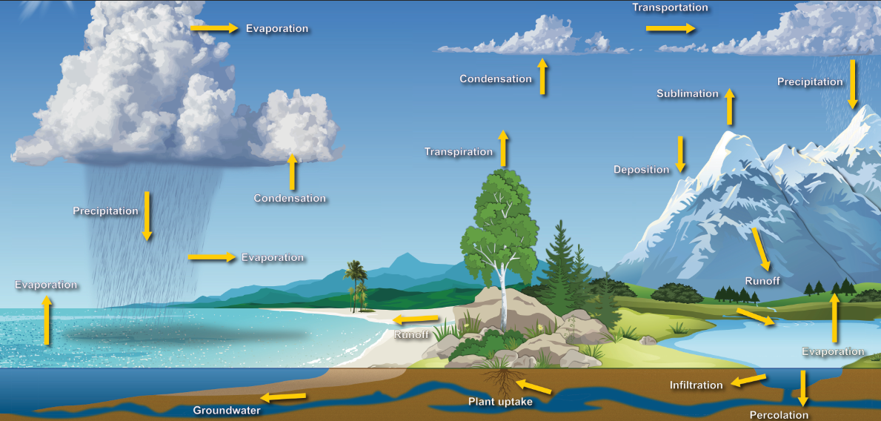
We have now learned about the water cycle and seen that it is driven by gravity and energy transfers. During this process water is found in all three states: solid, liquid, and gas. The water cycle is the environment's way of recycling the water on the planet (Figure 6). Of all the water on the planet, just 3% is freshwater. Only 1% of this fresh water is in accessible sources. The other 99% is in the form of groundwater (29%) and ice caps/glaciers (70%). Therefore, it is critical that we understand the water cycle so that we can protect our fresh water sources.
