Water ☔ Wonderland

**Part 1:**

*Beginning Thoughts*

1. Is water important to us? _______________________________________  
   ____________________________________________________________
2. What are three ways that you use water directly?  
    __________________________________________  
    __________________________________________  
    __________________________________________
3. What are three ways that you use water indirectly?  
    __________________________________________  
    __________________________________________  
    __________________________________________

|  |  |
| --- | --- |
| State of Water | Name |
|  |  |
|  |  |
|  |  |

1. What are the states that water can be in and what are they called?
2. Give examples of solid, liquid, and gas water in the atmosphere.  
    Solid: ______________________  
    Liquid: _____________________  
    Gas: _______________________

1. Where can we find water in the environment? ______________________  
   ____________________________________________________________
2. Are water sources a form of matter? (circle one) Yes No   
   Why or why not? ______________________________________________   
   ____________________________________________________________
3. How does the water enter these locations? _________________________  
   ____________________________________________________________
4. How does water leave these locations? ____________________________  
   ____________________________________________________________

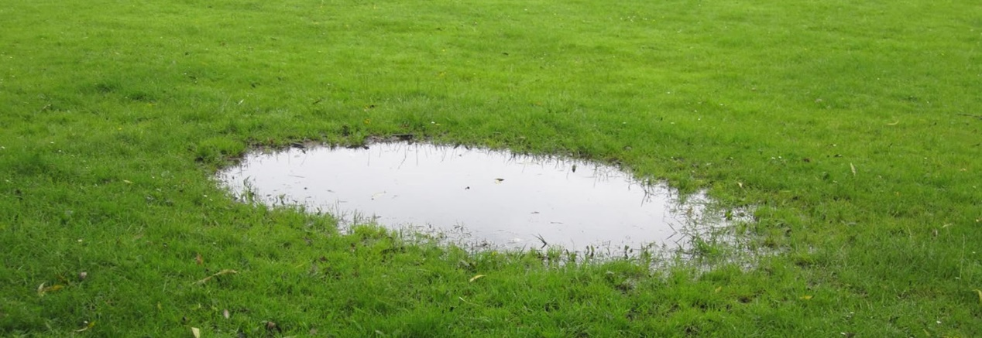

*How do Water Sources Interact?*

1. What is a model? ______________________________________________  
   ____________________________________________________________
2. Draw a model that shows sources of water and how that water moves. Label bodies of water with their appropriate names. Use arrows to show the direction of water movement.

Make a group Model

1. Does the amount of water in the system (Earth) change? (circle one) Yes No  
   Why or why not? ________________________________________________   
   ________________________________________________________________  
   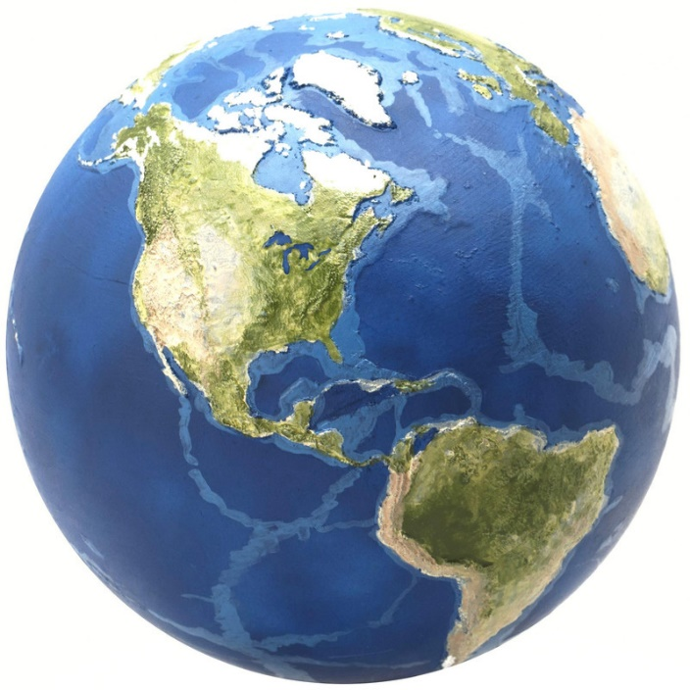
2. Give one example of a transfer of water (mass) in your system in which the state of matter **did not** change. Make sure to include where the water came from, where the water went to. _____________________________  
   ____________________________________________________________Was matter created or destroyed during this process? (circle one) Yes No
3. Give one example of a transfer of water (mass) in your system in which the state of matter **did** change. Make sure to include where the water came from, where the water went to. _____________________________  
   ____________________________________________________________Was matter created or destroyed during this process? (circle one) Yes No

**Part 2:**

*Why does water flow? (Part A)*

1. Watch demonstration 1 and record observations, what happened, and why. _______________________________________________________  
   ____________________________________________________________________________________________________________________________________________________________________________________
2. What does this demo have to do with the water cycle? _______________  
   ____________________________________________________________
3. How could you show this phenomenon in your model? _______________  
   ____________________________________________________________________________________________________________________________________________________________________________________
4. Watch demonstration 2 and record observation, what happened, and why. _______________________________________________________  
   ____________________________________________________________________________________________________________________________________________________________________________________________________________________________________________________________________________________________________________________________________________________________________________________________________________________________________
5. What happens to water that does not fall in a body of water? __________ ________________________________________________________________________________________________________________________________________________________________________________________________________________________________________________

Revise Model

**Part 3:**

*Why does water flow? (Part 2)*

1. Record observations from the start of demonstration 3 when the picture was taken. ___________________________________________________  
   ________________________________________________________________________________________________________________________
2. Describe what happened since the start of demonstration 3 and why this happened? ___________________________________________________  
   ____________________________________________________________________________________________________________________________________________________________________________________________________________________________________________________________________________________________________________
3. What was different between the start and end of demonstration 3? ____________________________________________________________

1. In the demonstration the lamp was a ______________________________ and the ice was a _____________________________________________.
2. What two science phenomena were seen in demonstration 3 and what are their reactions?  
   ________________________________________________________________________________________________________________________  
   Reaction:____________________________________________________  
   ________________________________________________________________________________________________________________________  
   Reaction:____________________________________________________
3. These phenomena are known as _________________________________, which always have __________________________ associated with them.
4. What could be like the lamp in your model? ________________________
5. What could be like the ice in your model? __________________________  
   ____________________________________________________________
6. When energy flows from the surroundings to the liquid water, it causes the water to turn to a ___________, which is known as _____________ . This causes the surroundings to ____________________. This should be shown in the model with an orange arrow pointed ___________________ liquid water.
7. When energy flows from the gaseous water to the surroundings, it causes the water vapor to turn to a _________________, which is known as _____________________________. This causes the surroundings to ___________________. This should be shown in the model with an orange arrow pointed ___________________ water vapor.
8. Are there any other water phase changes that we see in the water cycle and what are their reactions?  
   ________________________________________________________________________________________________________________________  
   Reaction:____________________________________________________  
   ________________________________________________________________________________________________________________________  
   Reaction:____________________________________________________

Revise Model

**Part 4:**

*Phase Changes Review*

1. Describe one process that happens in the water cycle that requires energy to transfer **into** water. Make sure to include the phase of water before and after the process. __________________________________________  
   ________________________________________________________________________________________________________________________ Was energy created or destroyed during this process? (circle one) Yes No
2. Describe one process that happens in the water cycle in which energy is transferred **out** of water. Make sure to include the phase of water before and after the process. __________________________________________  
   ________________________________________________________________________________________________________________________ Was energy created or destroyed during this process? (circle one) Yes No
3. How might desert plants get water if there is no rain? _________________  
   ______________________________________________________________________________________________________________________________________________________________________________________________________________________________________________________________________________________________________________________________________________________________________________

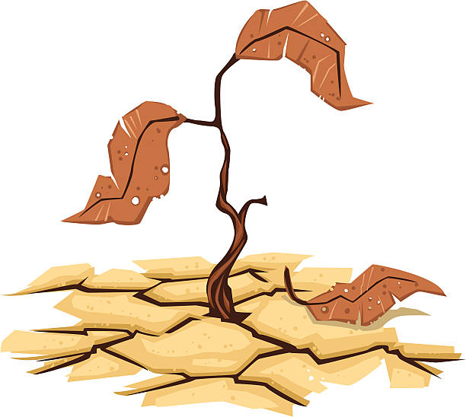

*Role of Plants in the Water Cycle*

1. Do you think plants play a role in the water cycle? (circle one) Yes No   
   If yes, what role do they play? ___________________________________  
   ____________________________________________________________
2. Record observations from the start of demonstration 4 when the picture was taken. ___________________________________________________  
   ____________________________________________________________
3. Describe what happened since the start of demonstration 4. ____________________________________________________________
4. How do plants play into the water cycle? ___________________________  
   ____________________________________________________________________________________________________________________________________________________________________________________
5. Do you think energy is associated with this phenomenon? (circle one) Yes No  
   If so, what does this energy transfer do to the plant? _________________  
   ________________________________________________________________________________________________________________________________________________________________________________________________________________________________________________

*Role of Animals in the Water Cycle*

1. Do animals play a role in the water cycle? (circle one) Yes No  
   If yes, what role do they play? ___________________________________  
   ____________________________________________________________
2. Perform demonstration 5 and explain what happened. _______________  
   ________________________________________________________________________________________________________________________
3. Do animals release water into the environment? (circle one) Yes No If so what is the phenomenon called? _____________________________

Work on Model

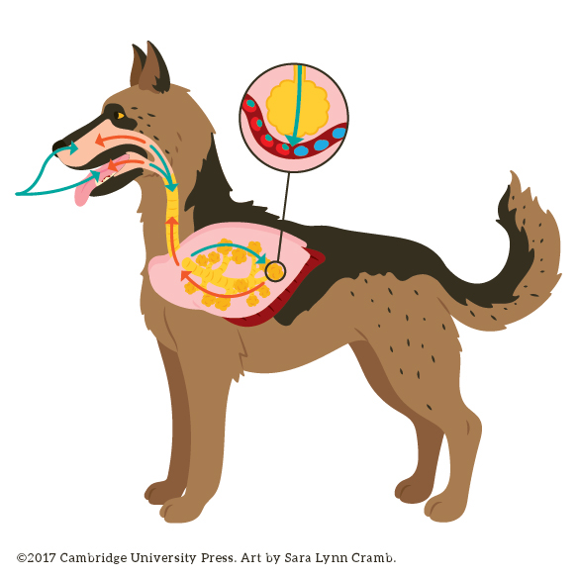

**Part 5:**

*Apply our Model of the Water Cycle*

1. Using your model, explain how people can pump out groundwater from one well for many years without it going dry. You must use 5 scientific terms (terms on pink stickies) in your explanation. Underline these in your explanation.  
   The scientific terms I will use are: ________________________________  
   ____________________________________________________________

Explanation: __________________________________________________  
____________________________________________________________________________________________________________________________________________________________________________________________________________________________________________________________________________________________________________________________________________________________________________________________________________________________________________________________________________________________________________________________________________________________________________________________________________________________________________________________________________________________________________________________________________________________________________________________________________________________________________________________________________________________________________________________________

*Verifying our model*

1. What is one thing that you learned about water in Santa Barbara? ______  
   ____________________________________________________________________________________________________________________________________________________________________________________

**Part 6:**

*Checking our Predictions*

Look back at question 42 to answer questions 44-46.

1. Does the reading support any of your answer? (circle one) Yes No  
   If yes, highlight the part of the reading that agrees with your answer and fill out the following sentence frames.   
   On page _____ it says __________________________________________  
   ____________________________________________________________ which agrees with what I wrote. In addition, on page ____ it says_______  
   ____________________________________________________________ which agrees with what I wrote.
2. Does the reading disagree with any of your answer? (circle one) Yes No   
   If yes, highlight the part of the reading that disagrees with your answer and fill out the following sentence frame.   
   On page ____ it says___________________________________________  
   ________________________________________________________________________________________________________________________ before the reading I thought_____________________________________  
   ____________________________________________________________
3. Go back to the reading and highlight one thing that you did not include in your answer, that you could have, to make it stronger. Summarize what you highlighted. _______________________________________________  
   ________________________________________________________________________________________________________________________

Revise Model

*Final Water Cycle Model*

1. Our group will discuss __________________________________________ I will be presenter _____ and I will talk about the following terms: ______  
   ____________________________________________________________  
   Facts I want to include in my presentation:  
   •___________________________________________________________  
   •___________________________________________________________  
   •___________________________________________________________