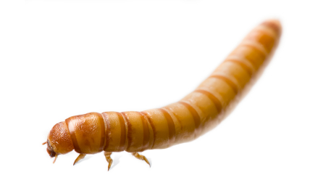
A Mealworm’s Bright Night Name:

Class Question: Will mealworms eat if it’s too bright?

The Experiment: Setup

Sun | Mon | Tues | Wed | Thurs | Fri | Sat
DARK | START! | LIGHT +  FOOD | X | LIGHT +  FOOD | START! | DARK

Class Setup: Circle what the whole class agrees to do for each part of the experiment.

- Number of Worms: 1 5 20 100

- Amount of Time: 30 seconds 5 minutes 1 Hour

Group Setup: Pick your experiment cards. Circle what your group will do for each part of the experiment.

- Brightness Level: 1 2 3
Classroom Light One Flashlight Two Flashlights
Least Bright Most Bright

- Food Type: Dry Oatmeal Apple Cracker

Prediction: I think more of the mealworms will travel towards the

FOOD / DARK (circle one) because _________________________

__________________________________________________

_________________________________________________.
Results: How many worms were in each compartment at the end? Use tally marks to count your worms in each box.

Sun | Mon | Tues | Wed | Thurs | Fri | Sat
DARK | START! | LIGHT +  FOOD | X | LIGHT +  FOOD | START! | DARK

- How many total worms went into the dark? ______

- How many total worms went into the light for food? ________

- Our group used brightness level ________ which was the LEAST / MIDDLE / MOST bright (circle one) and
DRY OATMEAL / APPLE / CRACKER (circle one) for food.
- More worms went towards the DARK / FOOD (circle one) because ____________ total worms went into the dark and ____________ total worms went into the light for food.
- Why do you think your worms acted this way? ____________
____________________________________________________________________________________________
Once you are done, help your teacher clean up!
Data Analysis: SHARE your findings to record on the class data sheet!

Independent Conclusion: (to be completed after class data analysis)

- The group with the most mealworms who went into the dark used brightness level _________ and ___________________________ for food.
- The group with the most mealworms who went towards the light and food used brightness level ___________________ and _________________________ for food.
- Overall the class experiments usually showed that MORE / THE SAME / FEWER (circle one) mealworms went into the light for food than went into the dark.

- Class Question: Will mealworms eat if it’s too bright?

If it’s too bright, mealworms _________________________
_______________________________________________
______________________________________________.

