Ecosystem Journal: Ponds and Lakes (Part 2 Day 2)
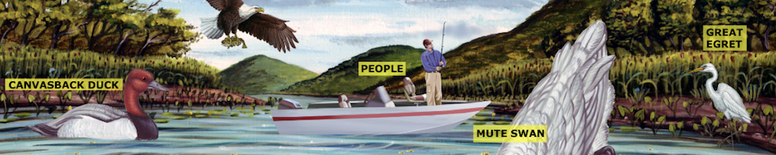

Name:___________________________________________
Directions: Use one of the FWARPS words for each sentence.

Food Water Air Reproduce Protection Shelter
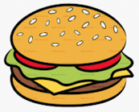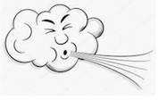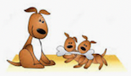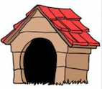

1. The willow tree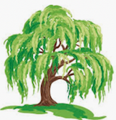 gets its ________________ by being located next to the
pond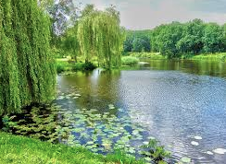.

2. The crayfish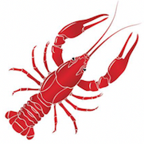 gets its _______________ by searching in the mud.

3. The crayfishalso digs a burrow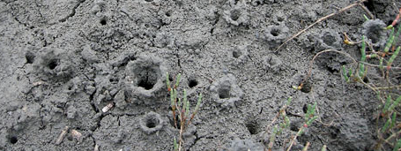 in the mud for _________________ from predators.
4. The cattail plants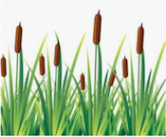 need sun, air, and _________________ to grow.

5. The beaver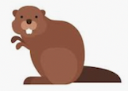 gets to make its ________________ with all of the fallen branches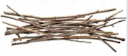 in this ecosystem.

6. The man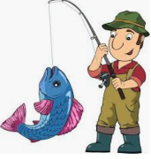 gets his __________________ by fishing in the stream next to the waterfall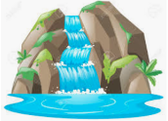.

7. The salmon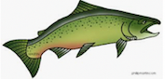 swims upstream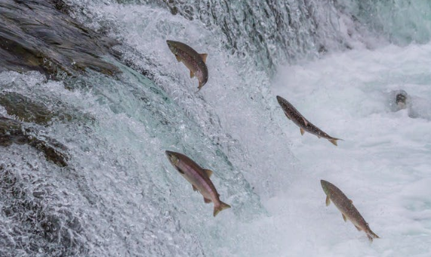 to find just
the right spot to lay her eggs and _______________________ baby salmon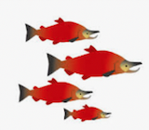.
Ecosystem Journal: Forests (Part 2 Day 3)
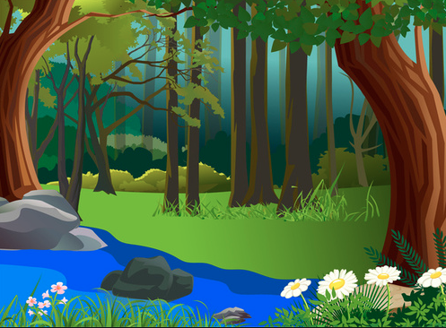

Name:___________________________________________
Directions: Use one of the FWARPS words for each sentence.

Food Water Air Reproduce Protection Shelter

1. The woodpecker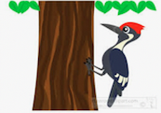 gets its ________________ by pecking into the tree bark looking for insects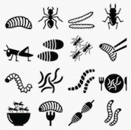 to eat.

2. The pine tree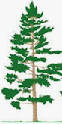 gets the __________________ it needs because its roots 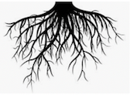 soak it up.

3. The owl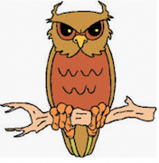 sits high in the tree branch for ____________________ from other animals and humans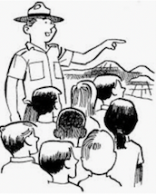.

4. The badger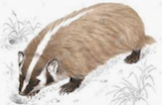 is probably looking for earthworms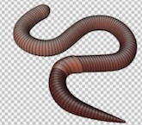, squirrels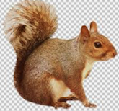 and

other small prey for ________________.

5. The logger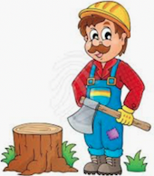 is cutting down the tree to use for making a _________________ for people.

6. The mountain lion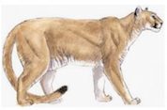 is most likely out hunting for __________________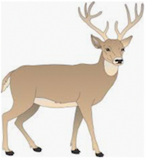.

Ecosystem Journal: Oceans & Coral Reefs (Part 2 Day 4)
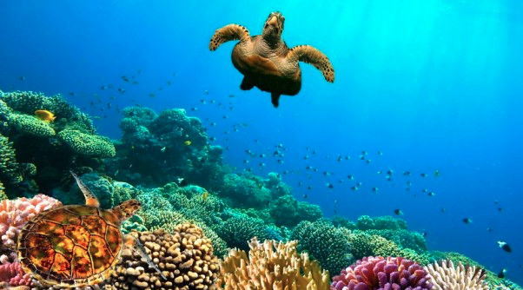

Name:___________________________________________
Directions: Use one of the FWARPS words for each sentence.

Food Water Air Reproduce Protection Shelter

1. Kelp forests 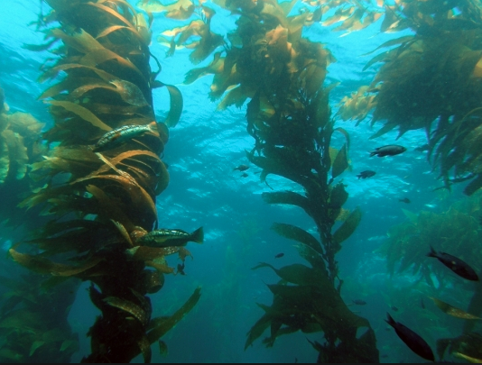 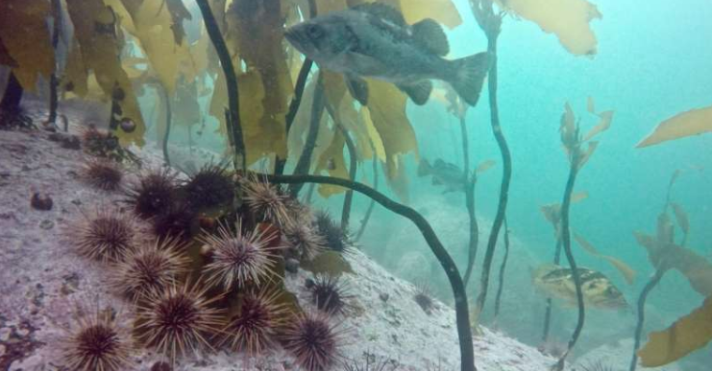 provide ___________________ for fish 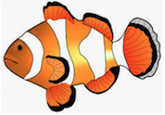 and urchins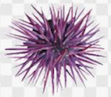.

2. The people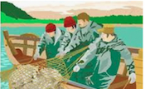 on the boat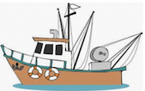 fish for _________________ to feed many other people .

3. These tuna fish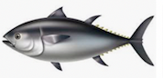 swim together for _______________________ from sharks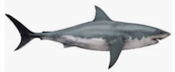 and other predators.

4. Dolphins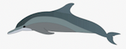 often swim in pods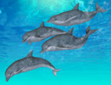. This helps them find a mate more easily

so that they can ________________________ and keep the species around.

5. Eelgrass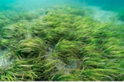 helps to provide __________________ for sea animals, like
crabs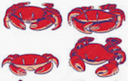 and prawns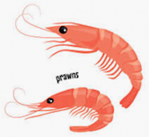 to eat.

6. This orange sea star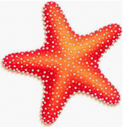 clings to the rocky bottom for ____________________ from ocean waves.
Ecosystem Journal: Deserts (Part 2 Day 5)
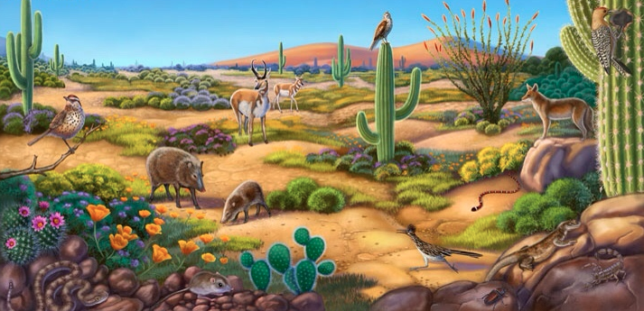

Name:___________________________________________
Directions: Use one of the FWARPS words for each sentence.

Food Water Air Reproduce Protection Shelter

1. The dense spines of the barrel cactus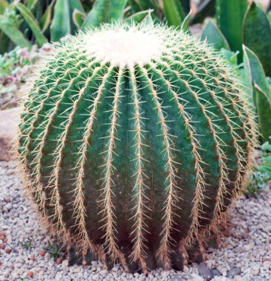 gives the plant
____________________________ from animals. 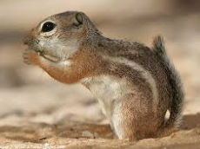

2. The scorpion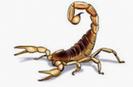 uses its stinger to catch its prey, such as the kangaroo rat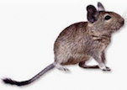,

for ______________________.

3. The roadrunner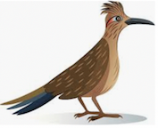 never needs to drink ___________________ because its gets enough to drink from the insects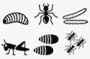, reptiles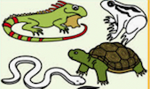, and fruits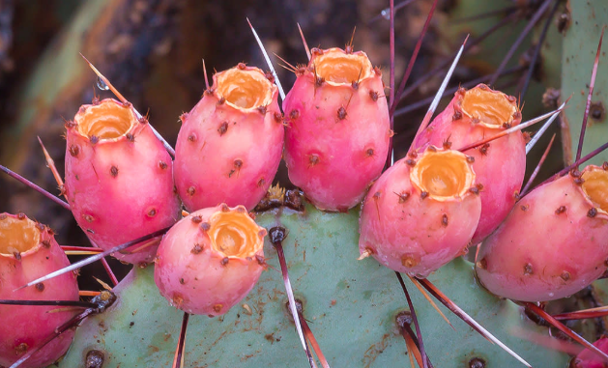 it eats.

4. When it’s time to _______________________ and make baby tortoises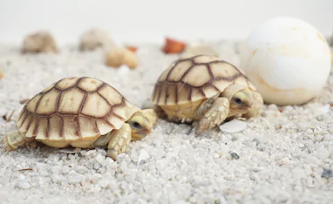, the desert tortoise 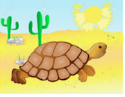 lays its eggs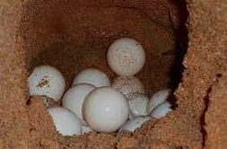 in a burrow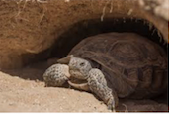 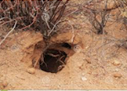.

5. Many animals, such as the roadrunner or scorpion eat the
kangaroo rat for ___________________ to survive.

