Name___________________________________________________________________

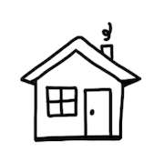

Draw a home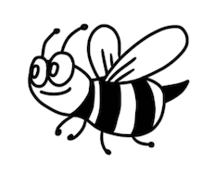

for a bee,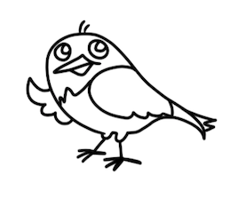

for a bird, 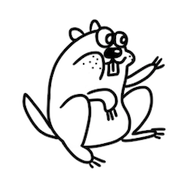

and a gopher.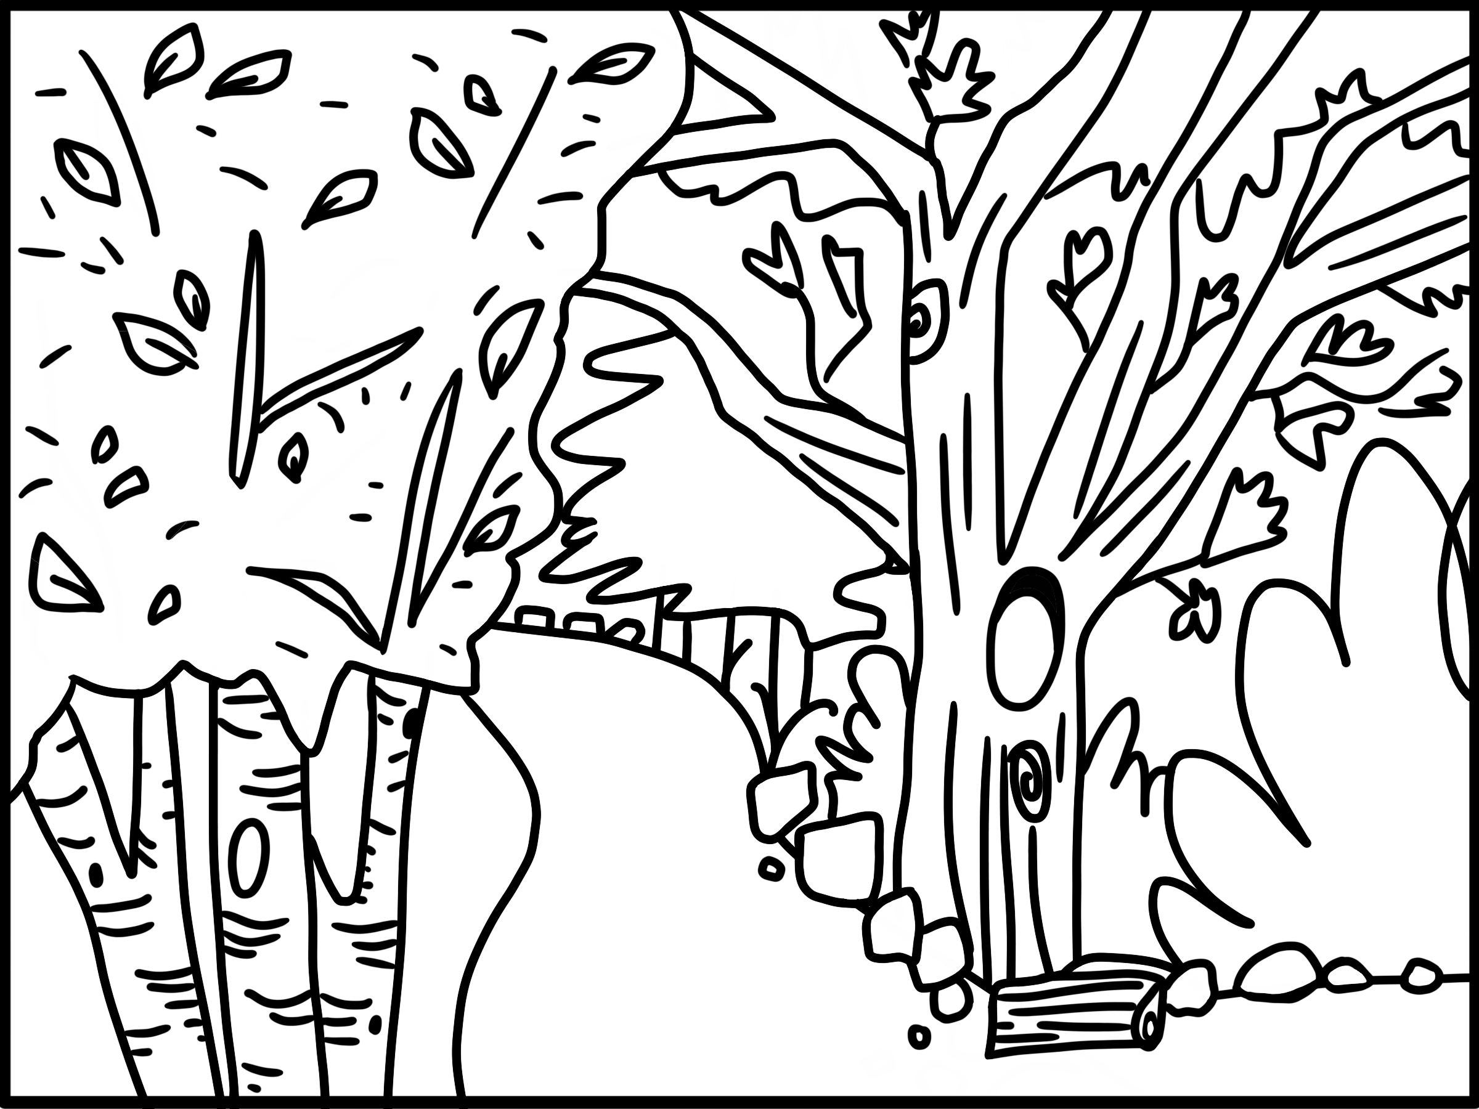

Name_________________________________________________________________

Draw how these things change the environment.

