Climate in the U.S.A.
PART 1

Class Question: How is climate different in different parts of the United States?

Climate: a description of an area’s normal weather conditions and how much those conditions vary over years.

Directions: Your group will be assigned a city to investigate.

What city was your group assigned? _______________________________________________________________

Use Google Maps to find your city. Draw a star where your city is on the map below:
Note: Alaska and Hawaii are actually located very far away from the contiguous U.S. and would be hard to accurately represent on a small map. They are shown at the bottom of the map.
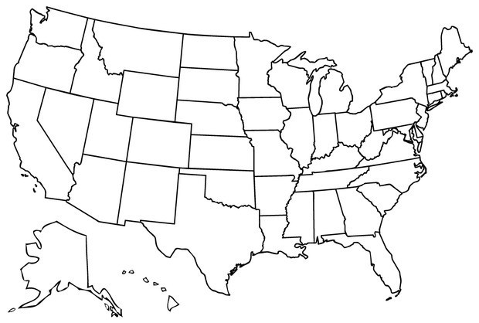

Write the name of your city onto the post-its from your teacher and put them on the correct location on each class map. Be ready to share the location of your city on Google Maps.

The two main factors we will investigate that help us describe climate in an area are temperature and precipitation.

- What is temperature?

- What is precipitation?

PART 2: Obtaining Climate Information: Temperature

Climate is the average temperature and precipitation in an area over a long period of time. To get a good idea of the climate in your city, you will look at data that spans 30 years of time! Look at the data tables for 2015, 2005, 1995, and 1985. Then make a bar graph that shows how the temperature changed each year. See your teacher’s example for help.

Temperature 2015: ____________________________________
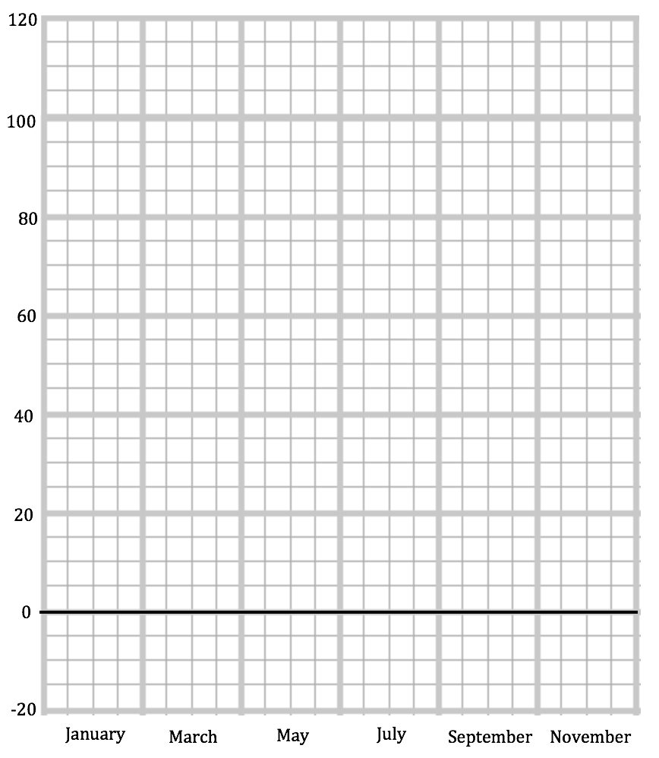

Coldest Month:

Temperature:

Hottest Month:

Temperature:

Range:

Temperature (°F)

Month

Temperature 2005: ______________________________

Coldest Month:

Temperature:

Hottest Month:

Temperature:

Range:

Temperature (°F)

Month

Temperature 1995: ________________________________

Coldest Month:

Temperature:

Hottest Month:

Temperature:

Range:

Temperature (°F)

Month

Temperature 1985:_______________________________

Coldest Month:

Temperature:

Hottest Month:

Temperature:

Range:

Temperature (°F)

Month

Evaluating Climate Information: Temperature

- Which year had the highest temperature? ______________________ What was it? ______________

Add this to the class bar graph. If 2 or more years are the same, include them all.

- Which year had the lowest temperature? _______________________ What was it? _____________

Add this to the class bar graph. If 2 or more years are the same, include them all.

- In what ways did the temperature remain stable over time?

_________________________________________________________________________________________________________
_________________________________________________________________________________________________________
_________________________________________________________________________________________________________
_________________________________________________________________________________________________________
- In what ways did the temperature change over time?

_________________________________________________________________________________________________________
_________________________________________________________________________________________________________
_________________________________________________________________________________________________________
- If you had to pick a normal year of temperature for this city, which one would you pick? Circle the graph you think best represents a normal year, and explain why below:

_________________________________________________________________________________________________________
_________________________________________________________________________________________________________
_________________________________________________________________________________________________________
_________________________________________________________________________________________________________
- For the year you chose as your normal year, add your data for each month to the class temperature map. Use this chart to decide which color sticker you should use for each month’s temperature. (You should have 6 stickers for your 6 months of data.)

Temperature Description | Color | Temperature Range
Very Hot | Red | 100 and above °F
Hot | Orange | 85 – 99 °F
Warm | Yellow | 65 – 84 °F
Cold | Blue | 33 – 64 °F
Very Cold | Black | 32 and below °F

~~~~~~~~~~~~~~~~~~~~~~~~~~~~~~~~~~~~~~~~~~~~~~~~~~~~~~

PART 3: Obtaining Climate Information: Precipitation

Now that you have looked at the normal temperature for your city, you will look at precipitation (precip.). Look at the data tables for 2015, 2005, 1995, and 1985. Use the prompts to help you add together the total precipitation for each season. If your city has snow, you will need to add the total precipitation (rain) and snow for each month. Then make a bar graph that shows how the precipitation changed each year. See your teacher’s example for help.

Precipitation 2015: _________________________________

Dec Precip. ___________ + Snow __________ = ______________
+
Jan Precip. ____________ + Snow __________ = ______________
+
Feb Precip. ___________ + Snow __________ = ______________
=
(measurements in inches) Total for Winter______________

Mar Precip. _____________ + Snow ___________ = ______________
+
Apr Precip. _____________ + Snow ___________ = ______________
+
May Precip. _____________ + Snow ___________ = ______________
=
(measurements in inches) Total for Spring______________

Jun Precip. _____________ + Snow __________ = ______________
+
Jul Precip. _____________ + Snow __________ = ______________
+
Aug Precip. _____________ + Snow __________ = ______________
=
(measurements in inches) Total for Summer_____________

Sep Precip. _____________ + Snow ___________ = ______________
+
Oct Precip. _____________ + Snow ___________ = ______________
+
Nov Precip. _____________ + Snow ___________ = ______________
=
(measurements in inches) Total for Fall______________

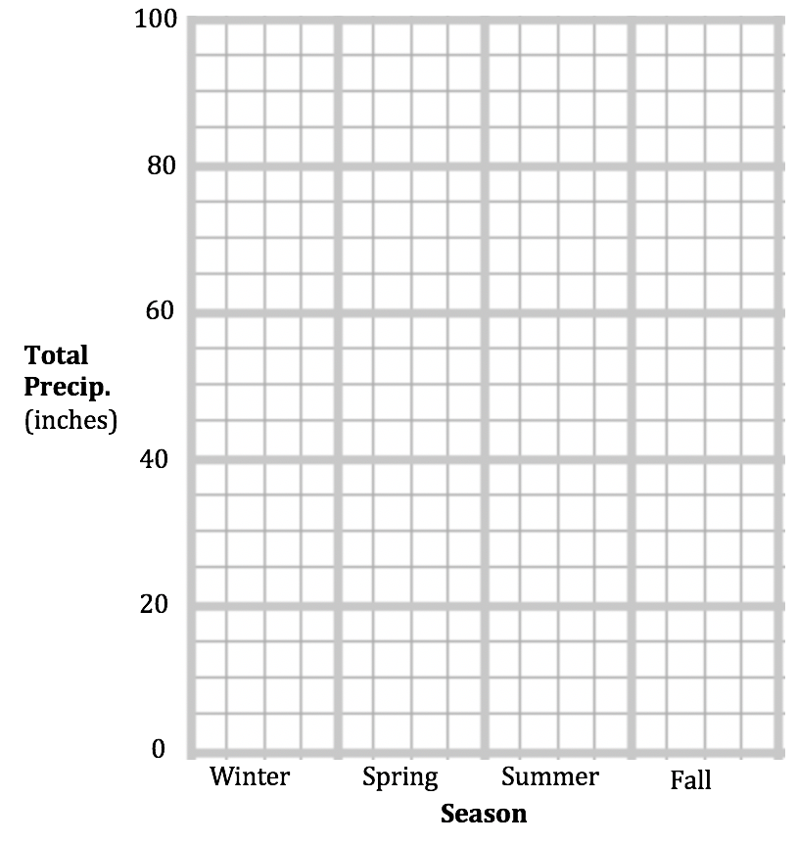
Season with most precipitation:

Amount:

Season with least precipitation:

Amount:

This year in my city, the amount of precipitation is mostly DIFFERENT / ABOUT THE SAME from season to season. (circle one)

Precipitation 2005: _________________________________

Dec Precip. ___________ + Snow __________ = ______________
+
Jan Precip. ____________ + Snow __________ = ______________
+
Feb Precip. ___________ + Snow __________ = ______________
=
(measurements in inches) Total for Winter______________

Mar Precip. _____________ + Snow ___________ = ______________
+
Apr Precip. _____________ + Snow ___________ = ______________
+
May Precip. _____________ + Snow ___________ = ______________
=
(measurements in inches) Total for Spring______________

Jun Precip. _____________ + Snow __________ = ______________
+
Jul Precip. _____________ + Snow __________ = ______________
+
Aug Precip. _____________ + Snow __________ = ______________
=
(measurements in inches) Total for Summer_____________

Sep Precip. _____________ + Snow ___________ = ______________
+
Oct Precip. _____________ + Snow ___________ = ______________
+
Nov Precip. _____________ + Snow ___________ = ______________
=
(measurements in inches) Total for Fall______________

Season with most precipitation:

Amount:

Season with least precipitation:

Amount:

This year in my city, the amount of precipitation is mostly DIFFERENT / ABOUT THE SAME from season to season. (circle one)

Precipitation 1995: _________________________________

Dec Precip. ___________ + Snow __________ = ______________
+
Jan Precip. ____________ + Snow __________ = ______________
+
Feb Precip. ___________ + Snow __________ = ______________
=
(measurements in inches) Total for Winter______________

Mar Precip. _____________ + Snow ___________ = ______________
+
Apr Precip. _____________ + Snow ___________ = ______________
+
May Precip. _____________ + Snow ___________ = ______________
=
(measurements in inches) Total for Spring______________

Jun Precip. _____________ + Snow __________ = ______________
+
Jul Precip. _____________ + Snow __________ = ______________
+
Aug Precip. _____________ + Snow __________ = ______________
=
(measurements in inches) Total for Summer_____________

Sep Precip. _____________ + Snow ___________ = ______________
+
Oct Precip. _____________ + Snow ___________ = ______________
+
Nov Precip. _____________ + Snow ___________ = ______________
=
(measurements in inches) Total for Fall______________

Season with most precipitation:

Amount:

Season with least precipitation:

Amount:

This year in my city, the amount of precipitation is mostly DIFFERENT / ABOUT THE SAME from season to season. (circle one)

Precipitation 1985: _________________________________

Dec Precip. ___________ + Snow __________ = ______________
+
Jan Precip. ____________ + Snow __________ = ______________
+
Feb Precip. ___________ + Snow __________ = ______________
=
(measurements in inches) Total for Winter______________

Mar Precip. _____________ + Snow ___________ = ______________
+
Apr Precip. _____________ + Snow ___________ = ______________
+
May Precip. _____________ + Snow ___________ = ______________
=
(measurements in inches) Total for Spring______________

Jun Precip. _____________ + Snow __________ = ______________
+
Jul Precip. _____________ + Snow __________ = ______________
+
Aug Precip. _____________ + Snow __________ = ______________
=
(measurements in inches) Total for Summer_____________

Sep Precip. _____________ + Snow ___________ = ______________
+
Oct Precip. _____________ + Snow ___________ = ______________
+
Nov Precip. _____________ + Snow ___________ = ______________
=
(measurements in inches) Total for Fall______________

Season with most precipitation:

Amount:

Season with least precipitation:

Amount:

This year in my city, the amount of precipitation is mostly DIFFERENT / ABOUT THE SAME from season to season. (circle one)

Precipitation 2005: ______________________________

Evaluating Climate Information: Total Precipitation (Rain and Snow)

- Which year had the season with the highest total precipitation? ________________

How much? ______________ inches Add this to the class bar graph.

- Which year had the season with the lowest total precipitation? ________________

How much? ______________ inches Add this to the class bar graph.

- In what ways did precipitation remain stable over time?

_________________________________________________________________________________________________________
_________________________________________________________________________________________________________
_________________________________________________________________________________________________________
_________________________________________________________________________________________________________
- In what ways did precipitation change over time?

_________________________________________________________________________________________________________
_________________________________________________________________________________________________________
_________________________________________________________________________________________________________
_________________________________________________________________________________________________________
- If you had to pick a normal year of precipitation for this city, which one would you pick? Circle the graph you think best represents a normal year, and explain why below:

_________________________________________________________________________________________________________
_________________________________________________________________________________________________________
_________________________________________________________________________________________________________
_________________________________________________________________________________________________________

continue to next page
- For the year you chose as your normal year, add your data for each season to the class precipitation map. Use this chart to decide which color sticker you should use for each season’s precipitation. (You should have 4 stickers for the 4 seasons.)

Precipitation Description | Color | Precipitation Range  (Per Season)
High | Purple | 27 and above inches
Medium | Light Blue | 12 – 26 inches
Low | Brown | 0 – 11 inches

continue to next page
PART 4: Evaluating Climate Information: Climate Type

There are five major types of climate. We can determine the climate of an area by using a system called Köppen climate classification, which organizes climates into categories based on temperature and precipitation. Use the information in your graphs and on the class maps to determine which type of climate your city has.

Köppen Climate Classification System
Climate Type | Temperature | Precipitation
A: Tropical | Warm, hot, and very hot temperatures (higher than 65°F) for all 12 months of the year. | Medium to High precipitation all 12 months of the year.
B: Dry | Can be hot or cold, but usually warmer during the day and colder at night. | Very low to no precipitation (0 to 1 inches) all 12 months of the year.
C: Temperate | Hot or warm during summers and mild cold (from 27°F to 64°F) during winters. | Medium winter and spring months, low the rest of the year.
D: Continental | Hot or warm summers with very cold (less than 32°F) winters. | Medium to High winter and spring months, low the rest of the year.
E: Polar | Cold or Very Cold (below 50°F) for all 12 months of the year. | Covered with snow and ice throughout the year.

We think our city is type ________________________________________________________

Write down three pieces of evidence you used to determine this:

- _________________________________________________________________________________________________
_________________________________________________________________________________________________
_________________________________________________________________________________________________
- ________________________________________________________________________________________________________________________________________________________________________________________________
_________________________________________________________________________________________________
- _________________________________________________________________________________________________
_________________________________________________________________________________________________
_________________________________________________________________________________________________
Communicating Climate Information: Climate Type and Weather Forecast!

You and your group will work together to create a short presentation about the climate in your city. Get the climate presentation templates from your teacher and decide who will be scientist #1, 2, and 3. Each of you will have your own part in the presentation.

~~~~~~~~~~~~~~~~~~~~~~~~~~~~~~~~~~~~~~~~~~~~~~~~~~~~~~

Conclusion Questions: Think about what your classmates presented and look at the classroom maps. You can also go talk to students in other groups if you are not sure.

- Which city has the highest temperatures? __________________________________________

- Which city has the lowest temperatures? __________________________________________

- Which city’s temperature remains the most stable throughout the year? ______________________

- Which city temperature changes the most throughout the year?________________________________

- Which city has the most precipitation? __________________________________________

- Which city has the least precipitation? __________________________________________

- Which city’s precipitation remains the most stable throughout the year? _____________________

- Which city precipitation changes the most throughout the year?_______________________________

Think back to our class question: How is climate different in different parts of the United States? Write at least three sentences. Use evidence from the lesson in your answer.

_________________________________________________________________________________________________________
_________________________________________________________________________________________________________
_________________________________________________________________________________________________________
_________________________________________________________________________________________________________
_________________________________________________________________________________________________________
_________________________________________________________________________________________________________
_________________________________________________________________________________________________________

My United States Climate Map
Using the information your classmates communicated, create your own climate map below. Label each city with its name. Then shade the area around the city with the correct color for the climate type. A: Tropical (Blue) - B: Dry (Red) - C: Temperate (Yellow) D: Continental (Pink) - E: Polar (Grey)

