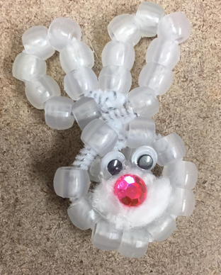
Name:

Bunny Burrows Day One

Discuss the problems for the bunny’s burrow.
Draw the problem and how you would solve it.

The problem is

.

I would fix it by

.

Bunny Burrows Day Two

In your group take your bunny into the sun. Draw and label a model of what the sun did to the bunny.

Word Bank:
sun bunny burrow hot
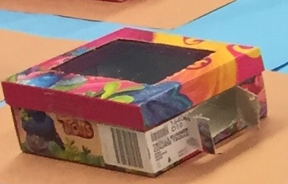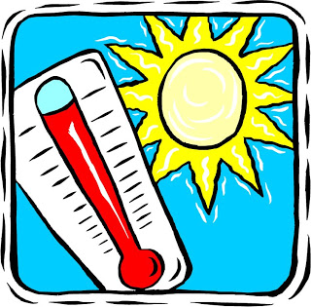

Bunny Burrows Day Three

Directions: Circle the picture of the material you will use.
Shade Materials:
Foil | Tissues | Wax Paper | Sunscreen
 |  | 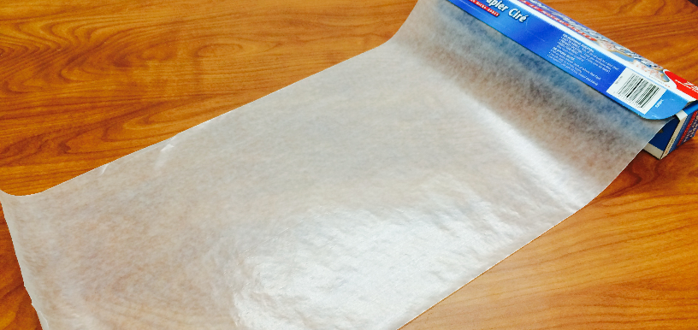 | 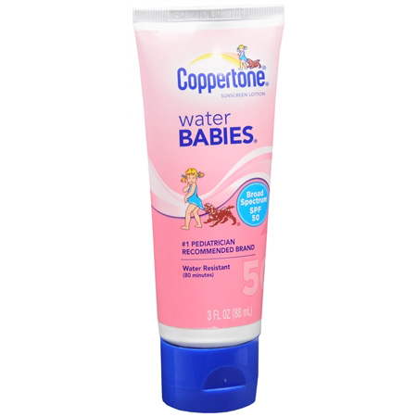
PREDICTION:
“We got and we think the bunny will

stay white change a little change a lot

because .”

Draw your bunny’s burrow with shade materials.

Bunny Burrows Day Four
RESULTS:
Our structure caused the beads to:
stay white change a little change a lot

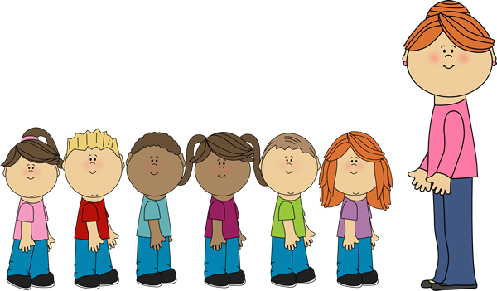
Label your bunny burrow with your result.
Parade by all the burrows to look for patterns.

was good for the

bunny because .

Discussion:

What do the burrows that stayed white have in common?

What do the burrows that changed have in common?

Prediction: What would happen if we covered the burrow in leaves?

