**Kinder Motion Lesson One**

Name: __________________

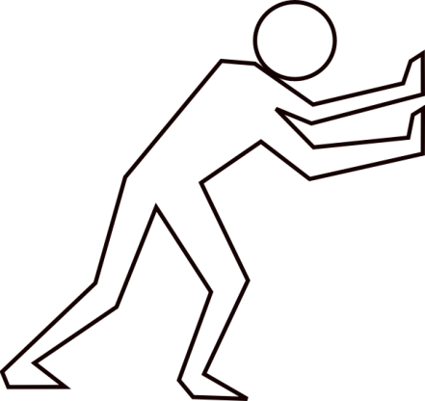

push

When you PUSH an object, it moves AWAY from you.

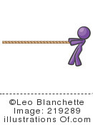

pull

When you PULL an object, it moves TOWARDS you.

Name: __________________

A ramp can make an object go faster.

**Kindergarten**

**Motion Lesson Two**

Circle the ball that will go the fastest.

Circle the ball that will knock down the box.

When an object moves faster it can give a stronger push.

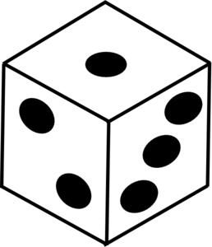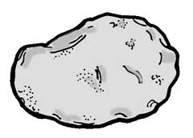

Circle the objects that were able to knock down the box.

Heavier objects can give a stronger push.

Draw a picture and write a sentence about what you learned today.

__________________________________________________________________________________________

**Name:_______________**

Kindergarten Motion Lesson Three

**Marble Roll**

**How will the marble roll to the floor?**

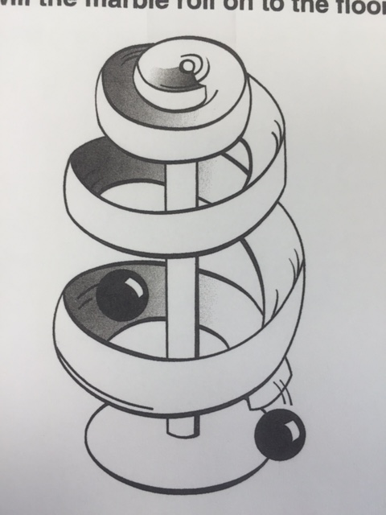

* **Straight**
* 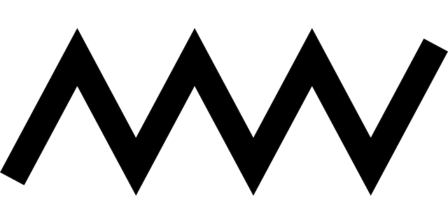**Curved**
* **Zig Zag**

**What makes you say that?**

**Marbulous Challenge!**

Questions:

1. When does the marble go SLOWER?
2. When does the marble go FASTER?
3. When does the marble CHANGE DIRECTION?

Build your own with only one beginning and end.

What team’s marble can roll the longest?

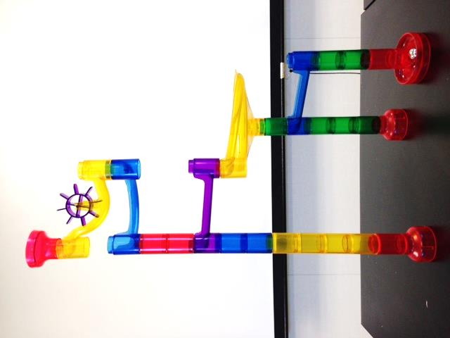

**Kinder Motion Lesson 4**

Name:_______________________________

**Simple Machines** are tools that can be used to change the speed or direction of an object. Draw a line to match each picture to the correct simple machine.

|  |  |  |
| --- | --- | --- |
|  |  | Ramp or Inclined Plane |
|  | Pulley |
|  | Wedge |
|  | Screw |
|  | Wheel and Axle |
|  | Lever |