The Fourth Little Pig’s House Design Challenge!
Name:____________________________
Team Color: __________________
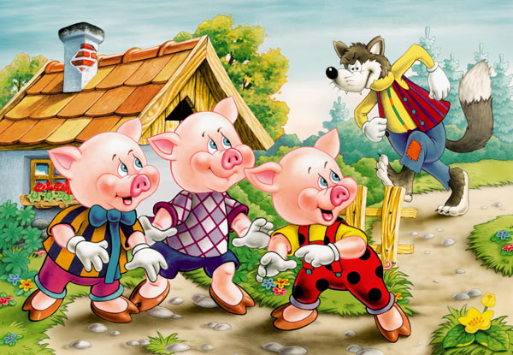
In the story of the Three Little Pigs, each pig builds a house out of different materials. Which materials were blown down by the wolf? Which material was strong enough to stay standing? Today your team will build your own house for a fourth little pig using different materials. Will your house be strong enough to protect the fourth little pig?

Objectives:
- Work as a team to design and build a house made of your choice of different materials.
- Test your house against the wind of the wolf, and make changes to your house as needed.
- Compare the different house designs in the class and decide what worked best, and what did not work very well.

What is an engineer? An engineer is a person who designs and builds complex products, machines, systems, or structures. Engineers want to know how and why things work. The three little pigs were engineers because they built their own houses from different materials. Today you will work together as student engineers to design and build a house that can stay standing in the wind of the wolf.

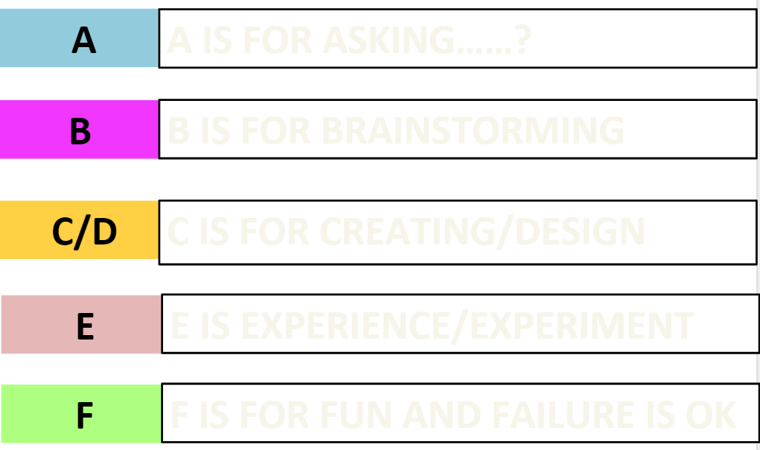
The ABC’s of engineering:

Materials: Just like the three little pigs and real engineers, you and your team must decide which materials you want to use. You will have $100 to spend on supplies for your house. Each material costs a different amount, and has different properties, such as strength, flexibility, texture, and hardness. Which materials will you buy and use to build your house?
The Store
Material | Cost
5 Small Index Cards | $5
1 Sheet of Aluminum Foil | $5
1 Meter of Yarn | $5
1 gram of Modeling Clay | $10
4 Pieces of Construction Paper | $10
5 Big Index Cards | $10
10 Straws | $10
10 Lego Pieces, Assorted | $20
1 Meter of Masking Tape | $20

Design Rules: Your house must:
- be able to stand on its own (cannot tape down to tray)
- have 4 walls, a roof, and a door your pig can fit through to enter and exit
- be built on a tray
Design Plan: Use the space below to draw and label a design of your house using the materials you plan to buy. Explain why you are choosing these materials. Once you have a design, bring it to the store to buy your materials.

I am choosing the ______________________ for the ___________________ because ______________________________________________________.
structure
material
I am choosing the ______________________ for the ___________________ because ______________________________________________________.
structure
material

Results and Conclusion: Use the space below to draw your final house design. Label the materials you used for each part of your house.

- Did your house stay standing in the wind from the wolf? ___________________________
_____________________________________________________________________
- What materials did you use? _______________________________________________
_______________________________________________________________________
- How much money did you spend? ____________
- In 1-2 sentences, explain why you think your house was or was not able to withstand the wind.
_______________________________________________________________________
______________________________________________________________________________________________________________________________________________
______________________________________________________________________
Comparing Houses in the Class
WORD BANK
BUILDING MATERIALS | BUILDING STRUCTURES
Small Index cards  Aluminum Foil  Yarn  Modeling Clay  Construction Paper  Large Index Cards  Straws  Legos  Masking Tape | Wall  Roof  Door  Side  Floor  Edge  Corner  Chimney  Bottom
What materials worked best for each building structure? Why?
The ______________________ worked well for the ____________________ because ______________________________________________________.
structure
material
The ______________________ worked well for the ____________________ because ______________________________________________________.
structure
material
The ______________________ worked well for the ____________________ because ______________________________________________________.
structure
material
What materials did not work well for each building structure? Why?
The ______________________ did not work for the ____________________ because ______________________________________________________.
structure
material
The ______________________ did not work for the ____________________ because ______________________________________________________.
structure
material
Application: Your teacher has built a house to protect the fourth little pig from the wolf. Observe your teacher’s house, and compare it to the houses you and your classmates built. Do you think your teacher’s house will protect the pig? Why or why not? Use the sentences below to show your thinking.

- I predict that my teacher’s house WILL / WILL NOT stand in the wind of the wolf.

- My teacher used __________________________ for the __________________ which will ________________________________________. I think this because _______________________________________________________________.
structure
material
- My teacher used __________________________ for the __________________ which will ________________________________________. I think this because _______________________________________________________________.
structure
material
- My teacher used __________________________ for the __________________ which will ________________________________________. I think this because _______________________________________________________________.
structure
material
- Did your teacher’s house protect the pig? _________________
- In 1-2 sentences, explain why you think your teacher’s house was or was not able to protect the pig: _____________________________________________________________
________________________________________________________________ ________________________________________________________________ ________________________________________________________________________________________________________________________________

