Name:______________________________

Engage #1: Scientific Practice Worksheet: Is the sound traveling?

Circle YES if the statement is demonstrating sound traveling. Circle NO if the statement is not demonstrating sound traveling
1. Mouth speaking 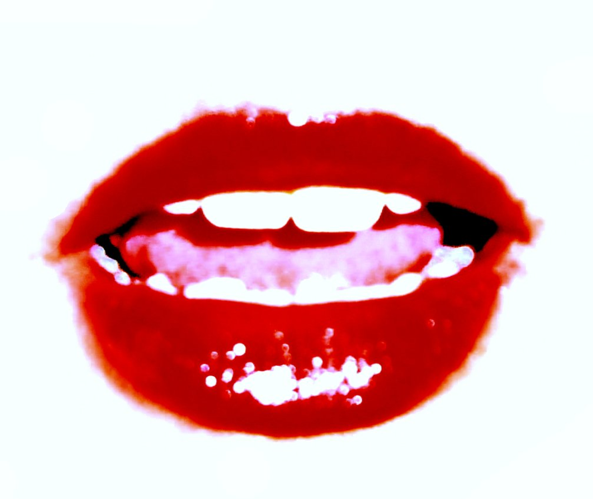 YES NO

2. Drum being hit 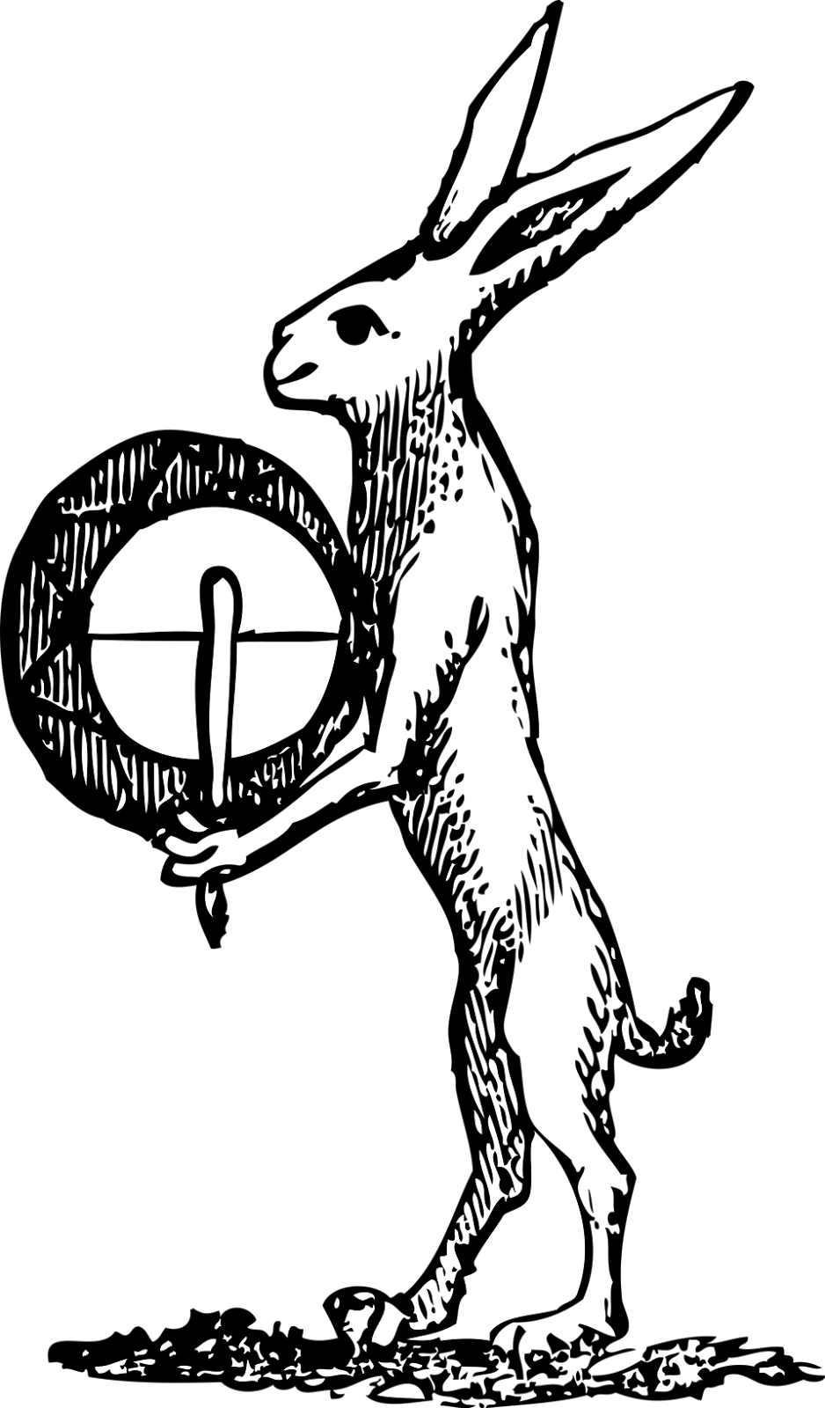 YES NO

3. Standing tree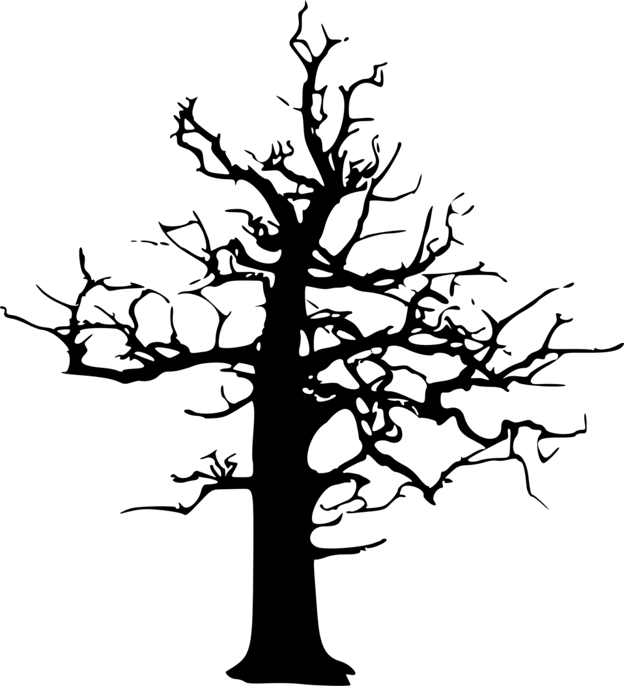 YES NO

4. Phone and ear listening YES NO

5. Baby sleeping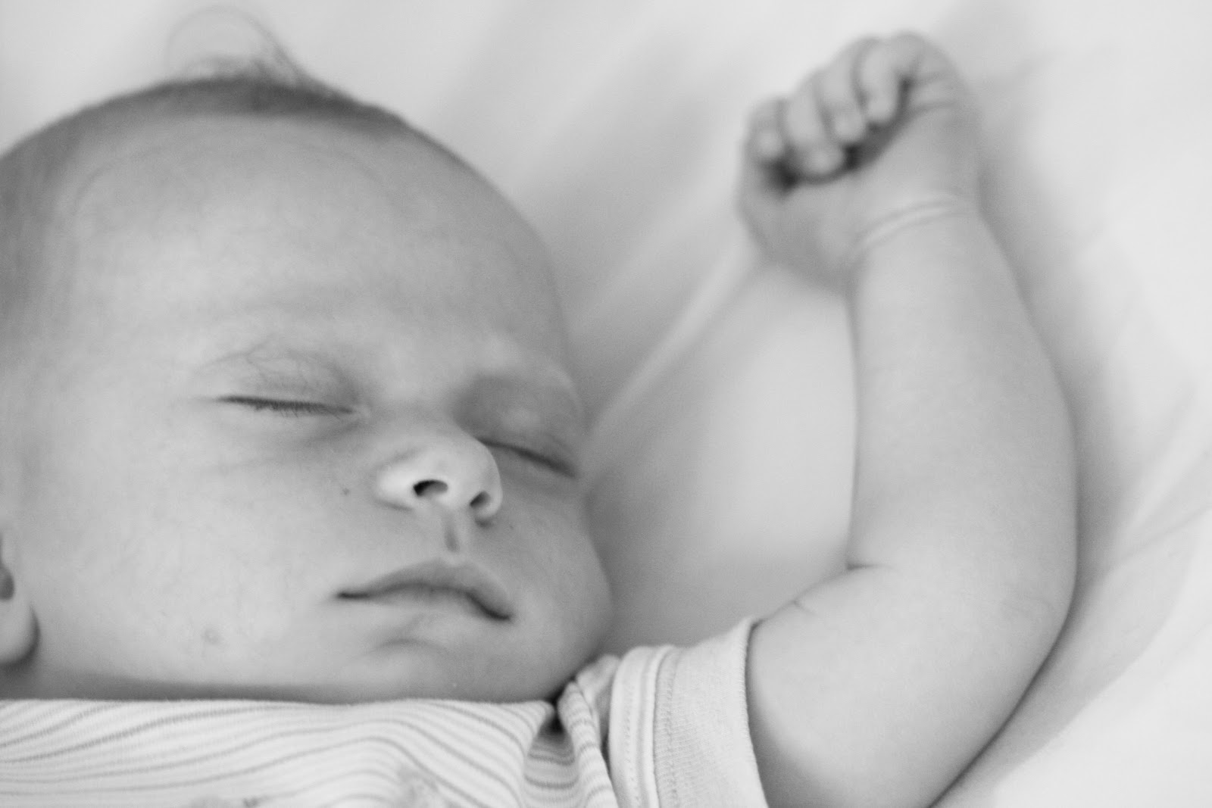 YES NO

6. In order to have sound, you need_____________________________________________________________

Whispering Through Tin Cans
1) What do you think will happen to the sound of someone whispering through a tin can?

Circle all the possible answers.
I will hear a buzz.
I will hear a hum.
I will hear the whispered words.
I will not hear anything.
2) Does shortening the string affect the sound?
YES or NO
3) The larger the string, the _________________ sound. (higher, lower)

Whispering Through Tin Cans
1) What do you think will happen to the sound of someone whispering through a tin can?

Circle all the possible answers.
I will hear a buzz.
I will hear a hum.
I will hear the whispered words.
I will not hear anything.
2) Does shortening the string affect the sound?
YES or NO
3) The larger the string, the _________________ sound. (higher, lower)
DATE: ______________

LAB #1: If we change the type of container what will happen to the amount of sound that we can hear?

Variables | Trial A | Trial B
Cup Material:  (changing variable)  String Length:  (constant) | Styrofoam cup  3 meters | Paper Cup  3 meters

Predict which cup will vibrate better and carry a louder whisper to your ear. Write your prediction below.

I predict that a whisper will cause a vibration and travel

better through a ____________________________ cup.

Date: _________________

TALLY SHEET (3 trials for each type of cup) ﻿

Can hear Cannot hear
Styrofoam cup telephone (Trial A)

Can hear Cannot hear
Paper cup telephone (Trial B)

GRAPH YOUR TALLY MARKS -color the number for each
3
2
1
Number of marks | Styrofoam Cup | Paper Cup

Results
From the tally marks, I understood that the ______________________cup

worked ______________________the__________________________cup
(better than / the same as)
for making a telephone.

**CLASS GRAPH**
_________students found that styrofoam cup caused the string to vibrate louder.
_________students found that the paper cup caused the string to vibrate louder.
_________students found that the sound was equal in both cups.

DATE:_______________
LAB #2: Does the size of the cup make a difference? How could we test that?
If we change the __________________________________ what will happen to how much we can hear?
Variables | Trial A | Trial B
Cup Material: (constant) | Paper | Paper
Cup Size:  (changing) | Large | Small
Yarn Length:  (constant) | 3 meters | 3 meters

I predict that a whisper will cause a vibration and travel

better through a _______________________ cup.

Date: _________________

TALLY SHEET (3 trials for each type of cup)

Can hear Cannot hear
Large cup telephone (Trial A)

Can hear Cannot hear
Small cup telephone (Trial B)

GRAPH YOUR TALLY MARKS -color the number for each
3
2
1
Number of marks | Large Cup | Small Cup

Results
From the tally marks, I understood that the ______________________cup

worked ______________________the__________________________cup
(better than / the same as)
for making a telephone.

**CLASS GRAPH**
_________students found that large cup caused the string to vibrate louder.
_________students found that the small cup caused the string to vibrate louder.
_________students found that the sound was equal in both cups.

